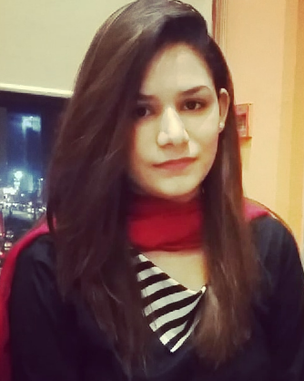
SANA ASHFAQ

MS Software Engineering
University of Agriculture, Faisalabad. (UAF)
(September 2017 to 2019).

PROFILE

Fathers name: Ashfaq Ahmed
Qualification: MS Software Engineering
Date of birth: September 12, 1995
C.N.I.C. No: 35403-0184705-6
Marital status: Single
Home/Postal address: P-189 Ali Block Muslim Town NO.1, Faisalabad, Pakistan
Email: sashfaq43@gmail.com
Phone no: +92-306-9059122, 041-8818437

CAREER OBJECTIVE
To serve an educational institute as a key member, that can effectively utilize its working skills and where I can enhance my knowledge and can contribute to the development of the organization.

EDUCATION AND QUALIFICATION

MS Software Engineering | 2017-2019 | University of Agriculture Faisalabad | 3.75/4
BSc. Software Engineering | 2013-2017 | University of Agriculture Faisalabad | 3.77/4
F Sc.(Pre Engineering) | 2011-2013 | Sandal College Faisalabad | 892/1100
Metric | 2011 | Sandal College Faisalabad | 923/1050

.

PROFESSIONAL EXPERIENCE

- 1 year experience as internship in Laboratory Girls Higher Secondary School Faisalabad
- 3 Months experience in Aptech College Faisalabad

COMPUTER LITERACY

- Application Software
(MS Office, Excel, PowerPoint, VS2010, Adobe Photoshop)
- Programming Language
(C++, C#.net, PHP, Java Script, OOP)
- Web Developing
(HTML, CSS, Bootstrap)

PERSONAL SKILLS & QUALITIES

- Good Presentation and Communication Skills
- Ability to conduct research and write reports
- Good Management Skills

INTEREST
- Designing

PROJECTS:
- Computer Science Speaking Dictionary (C# and SQL)
- Al-Noor Hospital Management System Desktop Application (C# and SQL)
- Smart Home Automation System (Arduino)

