Curriculum Vitae
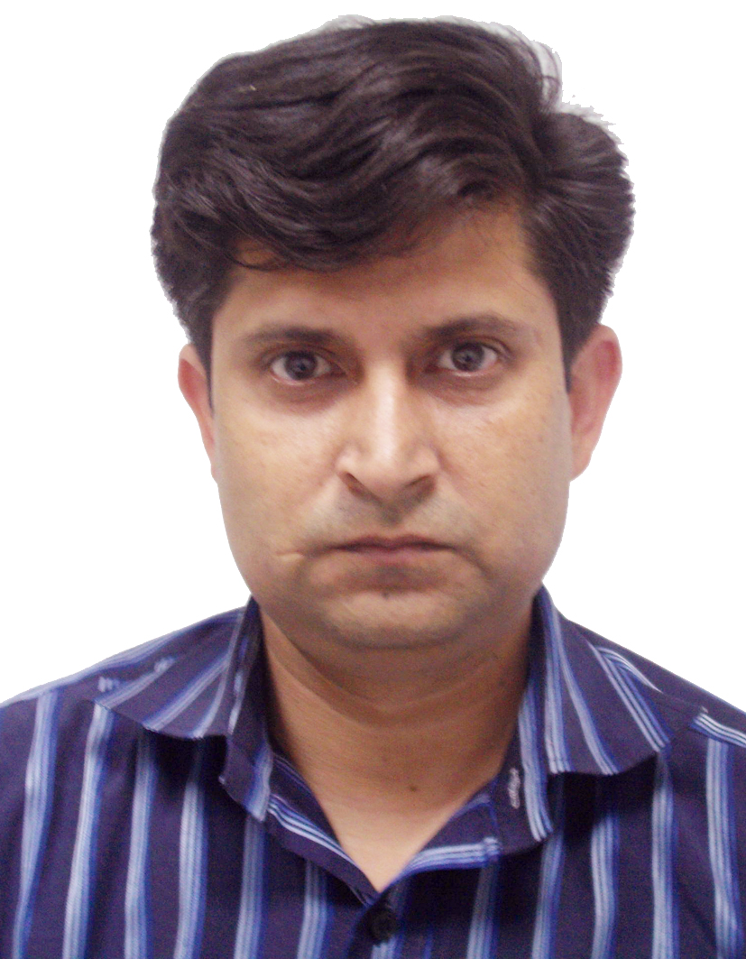

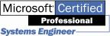
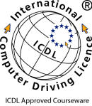



Personal Data:
Name: Kashif Ehsan Sharwani
Birth Date: 3rd Aug 1974.
Birth Place: Pakistan.
Address: Gujranwala Pakistan
Tel. No : +971 50 9177892
Email: kashif.sharwani@gmail.com
Martial Status: Married

Education:
1997 - 1999
- BCs Bachelor of Computer sciences from ICT Lahore Pakistan.
1995 – 1996
- DCH Diploma in Computer Hardware Engineer from Quaid-I-Azam College of Computer Sciences Lahore Pakistan.
1994 – 1995
- Higher Secondary School Certificate:
1992 –1996
- DAE Diploma Associate Engineer (Mechanical Technology) from Govt. Polytechnic Institute Sialkot Pakistan.
1989 – 1990
- Secondary School Certificate:
Dastgir Ideal School Gujranwala, Pakistan
Certifications:
- OCP (Oracle Certified Professional) Developer Track
- INTRODUCTION TO ORACLE, SQL PL/SQL.
- DEVELOPER PL/SQL PROGRAM UNIT
- DEVELOPER 2000 BUILD FORM1
- DEVELOPER 2000 BUILD FORM II
- DEVELOPER 2000 BUILD REPORTS
- MCP (Microsoft Certified Professional) ID 1883945
- NE (Networking Essential)
- WINDOWS NT SERVER 4.0
- WINDOWS NT WORKSTATION 4.0
- ENTERPRISES
- MCSE (Microsoft Certified System Engineer)
- SQL ADMIN
- TCP/IP
- MCSE 2000
- INFRA STRUCTURE
- ACCELERATOR
- International Computer Driving License (ICDL)
- A+ (Hardware and Operating System)
- CTP (Certified Trainer Professional)

Training Topics:
- Oracle Developer 6i

- MCSE (Microsoft Certified System Engineer)
- Microsoft Office (97, XP, 2003 and 2007 )
- ICDL (XP, 2003 and 2007)
- A+ (Computer hardware and operating system)
- CTP (Certified Trainer Professional)

PROJECT
1) Configured the network for Computer College’s labs.
2) Configured the network for internet cafes.
3) Configured the network for HBL (Habib bank limited).
4) Configured the network for PTCL (Pakistan telecommunication) Exchange

Work Experience:
Date | Job Title | Company | Work Details
My Last Work Experience
March 2005: September 2018 | ICDL Test Center Manager  PearsonVUE admin | Al Dar University College in Dubai | IT Support  ICDL TEST CENTER MANAGER  VUE ADMINISTRATOR  PROMETRIC ADMINISTRATOR  ICDL Trainer  Assistant Registrar
Employment History
Oct 2002 :  Oct 2004 |  | Mobile Communication | Montana Trader Square Pretoria Free Market Pretoria South Africa.  As a Sales man Cell phone and Computer and Computer engineer
Jan2001 :  Sep 2002 | Instructor | Pics computers | As a Network Administrator and hardware incharge in Computer Lab.  Work as network manager and computer trouble shooting in field  Operating system Windows NT server 4.0 and Windows NT workstation 4.0  Operating system Windows 98  Operating system Windows 2000.
Jan 2000 :  Dec 2000 | Instructor | National Institute of Computer Education | As network administrator in computer Lab. Windows Nt 4.0 Operating System.  Windows 2000, Windows 98
Jan 1995 :  Dec 1999 | Maintenance engineer | Kam Enterprises | 32 Ist floor Hafeez Center Gulberg III Lahore.  As a Network Administrator and Hardware Engineer in lab.  Work as network Configured and computer trouble shooting in field

Computer Experience:
* Specialist in Microsoft Office:
Windows xp, all office 2000 Products & office xp products & office 2003 and office 2007
* Professional Database with:
Oracle Developer 6i, Microsoft Access
* Professional Networking with:
- WINDOWS NT SERVER 4.0
- WINDOWS NT WORKSTATION 4.0
- Windows 2000, 2003, XP

.

