MUHAMMAD MAQBOOL
Chief Warrant Officer (Retd), Pakistan Air Force
Mobile No: 0307- 5852994
E- Mail ID: maqbool.qaiser68@gmail.com
Present & Postal Arab Colony near Minhaj Post Graduate
Address: College, Qutba Morr, Kamra Cantt.
District Attock

Permanent Address: Vill Kotly Jattan Post Office Noor kot Tehsil Shakar Garh Distt Narowal

               
       

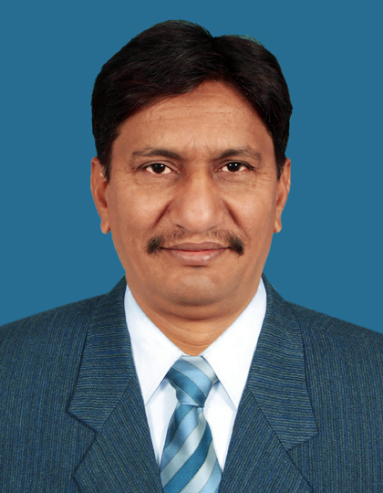

CAREER OBJECTIVES

Seeking career oriented position in a challenging organization where I can utilize my qualification and experience working with honesty and dedication as an integral part of a professional enterprise, so that I can fully apply my knowledge and enhance my learning as well.

Personal Details
- Father’s Name : Jamait Ali
- Date of Birth : 06 April,1968
- CNIC : 34502-1559495-9
- Domicile : Punjab
- Nationality : Pakistani
- Marital Status : Married
- Religion : Islam

ACADEMIC QUALIFICATION
Certificate / Degree | Discipline / Subject | Passing Year | Board / University | Div / Grade / %age of marks
Matric (Science) | Physics, Chemistry, Mathematics, Biology | 1983 | Board of Intermediate & Secondary Education, Lahore | 1st / A / 76.24%
Intermediate (F Sc) | Physics, Chemistry, Mathematics | 1986 | Board of Intermediate & Secondary Education, Gujranwala | 2nd / D / 48.27%
Bachelor (B. A) | Economics, Islamiyat | 1992 | University of the Punjab, Lahore | 2nd / C / 57.88%

PROFESSIONAL COURSES

Training / Certificate | Discipline / Subject | Passing Year | Institution | %age of marks.
DAE In Photo Technology | Airborne / Ground Photographic systems | 1989 | SOA, Pakistan Air Force | 62.12%
Military Leadership and Command Course | Management, Leadership | 2005 | JCO Academy, Pakistan Air Force | 74.18%
JCO Supervisory Course | Administration | 2005 | SOA, Pakistan Air Force | 73.76%
Computer Familiarization Course | MS office, Internet | 2011 | BTS, Pakistan Air Force | 80.00%

EXPERIENCE
- Retired from Pakistan Air Force as Chief Warrant Officer after completion of 25 years regular service. Have experience in Photo Technology, Office / admin management, Conversant with computer operations, , Monitoring and Evaluation, Internal quality auditing as per Quality Management System, Security Supervision.
Name of Organization | Post Held | From | To | Nature of Experience
World Health Organization  (EPI – Punjab), Pakistan | District Monitor (UNV) - Measles SIA  (District Attock) | Sep 2018 | Nov 2018 | - Conduct measles campaign readiness assessment at UCs & district level using WHO tool.  - Monitor quality of preparatory activities; (Trainings / orientations, management meetings, ACSM activities, AEFI management) conducted at district, Tehsil and UC level.  - Conduct meetings with community leaders for support / cooperation during campaign.  - Conduct supervision of measles campaign using observers’ checklist as per guidelines.  - Collect field data from Health Facilities as per guidelines and submit online through android phones.  - Conduct Rapid Convenience Assessment (RCA) using prescribed tool.  - Attend daily evening meetings with CEO (Health) / DC.
Population Welfare Department  (Punjab) | Monitoring and Evaluation Assistant  (District Narowal) | Jan 2016 | Dec 2017 | - Conduct regular field visits of Family Welfare facilities as per specified time schedule and submit daily fields visit report.  - Collect comprehensive field data from Family Welfare Facilities as per the SOPs of the organization.  - Submit the collected field data through android phones (Tablet).  - Maintain Facilities record (activity photographs, minutes of meetings and field monitoring reports) at district level.  - Prepare a monthly progress report of activities performed during the month.  - Ensure adherence to department policies and procedures.  - Attend monthly project implementation meetings with DMO.
Canteen Stores Department  (Lahore Zone) | Security Supervisor  (Security / vigilance Branch) | Jul 2013 | Jul 2014 | - Conduct regular field visits to business venue as per specified time schedule and submit daily fields visit report.  - Collect comprehensive field data from CSD Shops as per the SOPs of the organization.  - Maintain security of entrance and exit points of the Shops.  - Submit the collected field data online via Emails to Head Office.  - Prepare a monthly progress report of all field activities performed during the month.  - Ensure adherence to Business policies and procedures and undertake disciplinary actions.  - Carry out surprise stock takings (SST) of CSD shops.  - Feeding Updates to Head Office regarding robbery cases.
Pakistan Air Force / Pakistan Aeronautical Complex, Kamra | Administration / Supervision  (Office / admin management) | June 1989 | Mar 2012 | - Administration / supervision of scheduled photographic activities held at PAC secretariat, Factories and PAF Formations.  - Maintain office records / documents.  - Carry out drafting and typing of official correspondence.  - Perform General Reception duties and work related errands.  - Maintain office supplies and inventories of non-expendable items. Arrange any repair or replacements.  - Handle financial transactions of all property associate expenses and record office expenditures.  - Maintenance of living accommodation and supervise janitorial staff.  - Obtain quotations, place orders for contractors and receive deliveries efficiently.  - Administration / housekeeping of office equipment / material stores and maintain stock records cards / registers.  - Carry out audits of different formations as directed by Air Headquarters.  - Feeding updates to Head Office regarding Budget allocations and expenditures.  - Perform security supervisory duties.
ABILITIES

Languages
- Planning, organizing, scheduling and monitoring.
- Able to complete task within available resources even in short span of time.
- Excellent interpersonal and communication skills.
- Self-starter attitude and good team player.
- Proficient in use of IT equipment (Computer, Tablet, MS Office).
- Having own conveyance (Motor Bike & valid driving licence).

Languages

- English. (Read, write, speak)
- Urdu. (Read, write, speak)
- Punjabi (Read, write, speak

EXTERNAL SKILLS

- Friendly, co-operative , honest, hardworking

