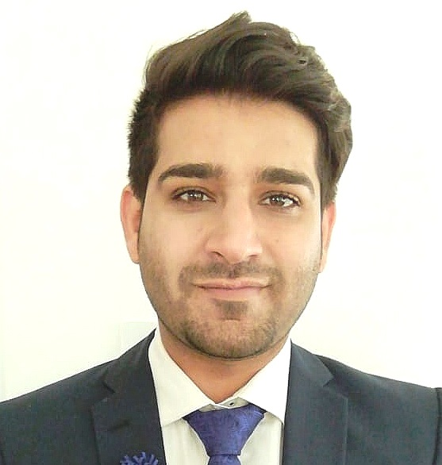
OMER ASIF
| Mobile : +92-312-413 6324 | E-mail : omerasif2019@gmail.com | Skype ID: live:omerasif2019 |

SUMMARY

An Enthusiastic.Professional Engineer And Teacher with experience working in the Industry and associated with the Academia along the path.
CORE COMPETENCIES & SKILLS

| PROGRESS MONITORING | STRONG ANALYTICAL SKILLS |TIME MANAGEMENT| CRITICAL THINKING | ADAPTABILITY | QUALITY FOCUS | TEAM PLAYER AND ORGANISATIONAL SKILLS| COMMUNICATIONAL AND NEGOTIATION SKILLS | EFFECTIVE PROBLEM SOLVER | MS OFFICE ( WORD EXCEL & POWERPOINT) PROFICIENCY | MATLAB | ETAP | PROTEOUS 7.6 SIMULATION TOOL | AUTO CAD (ELECTRICAL) | PROJECT MANAGEMENT TRAINING | PV SOLAR POWER RENEWABLE SYSTEM | ARDUINO PROGRAMMING | INTERNET OF THINGS (IOT) APPLICATIONS |

Professional Experience


PROJECT/ELECTRONICS ENGINEER | Siddique Sons Engineering (Pvt.) Ltd, Lahore, Pakistan | |Nov 2016 to Mar 2019 |

Key Responsibilities:

- Ensure successful operation of electrical and allied systems installed in factory by managing team of supervisors and technicians.
- Initiated, planned, executed and effectively closed delivery of Material Grid Station equipment as per contract drawings.
- Prepared Government and private tender documents and negotiate contract terms.
- Coordinated with both current and potential clients to develop existing and new business opportunities.
- Reviewed customer drawings, plans and other documents in order to prepare detailed technical proposal.
- Coordinated timelines with the production team for the manufacturing and with the supplier for the supply of material from abroad (CHINA, UK etc).
- Produced Inspection test plans and supervised testing of Material with Client inspectors at company factory.
- Submitted reports, estimated and all applicable monitoring reports on regular basis.
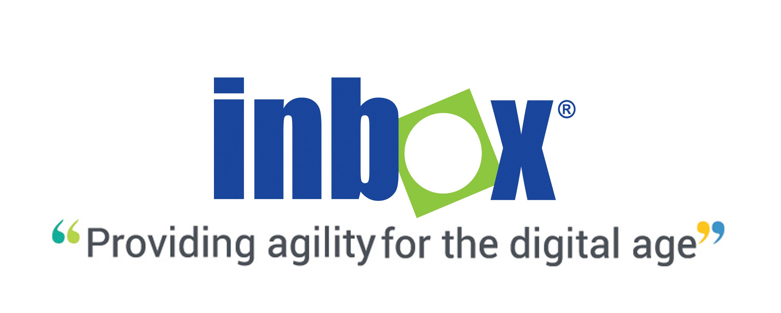
.
RESIDENT ENGINEER | Inbox Business Technologies (Pvt.) Ltd, Lahore, Pakistan |
NOV 2014 to Nov 2016 |

Responsibilities:
- Scheduled and have undertaken periodic maintenance on all Electrical equipment/ systems ( Generators, MCCs, Transformers, UPS & DC System etc.. ) , ELV equipment (Turnstiles, Vending Machines & On Board Units ) and new software upgradation routines.
- Circuit analysis, simulation and testing in inverter and SMPS circuits.
- Final designing Fault finding in PCB & Circuit.
- Testing of PCBs, Connectors, Power Supplies and Signal Conditioners.
- Knowledge in Power Electronics, DC-DC Converters, SMPS Full Bridge, Half Bridge.
- Provided first level support for hardware & software over phone, email and/or site visit.
- Configured and tested both the hardware & software of KENTkart.
- Troubleshooted all technical issues and provided timely service to all customers.
- Managed directly and provided technical support to all electrical work groups at site.
- Installated GPON Sites (OLT, ODF and Rectifier) & Configured OLT & ONTs (internet and SIP service) .
- Periodic maintenance of Routers.
- Submitted monthly report of Issues and resolution to the Higher management.

Achievements :
- R&D of Dispenser Box of Token Vending Machine.
- Out of the Box Award – for the implementation of JIRA Software for the efficient execution of Projects running and to enhance Team coordination.
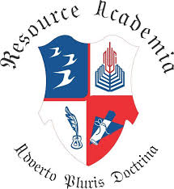
TEACHER | RESOURCE ACADEMIA, Lahore, Pakistan | July 2012 to Nov 2014 |

Responsibilities:

- Taught Mathematics,Chemistry and Physics to O level students.
- Prepared lesson plans, lecture materials and actively involve in developing
- curriculum.
- Prepared and submits planning and other projects on time.
- Identified clear teaching and learning objectives by specifying how they will be taught and
- assessed.
- Ensured students acquire and consolidate knowledge, skills and understanding appropriate to
- the subject taught.
- Checked the students work efficiently and thoroughly.

ACADEMIC PROJECt

Title: Induction Furnace (Power Electronics Based Project)
Scope of the project was to provide efficient, consistent and controllable heat up to 600 degrees centigrade within seconds, project comprised of following circuitry - Inverter (using MOSFET IRFP-460) - Control circuit (using IR-2110) - LC circuit.

Educational credentials

- M.Sc. Electrical Engineering (Power Electronics) (Year 2016) University of Central Punjab, Lahore, Pakistan.
- B.Sc. Electrical Engineering (Year 2012) University of Central Punjab, Lahore, Pakistan.
- A-LEVEL ( Pre Engineering) (Year 2008) Resource Academia, Lahore, Pakistan.
- O-LEVEL (Science) (Year 2006) Cathedral High School, Main Branch, Lahore, Pakistan.
- Project Management Training (PMI- PDU’s) (2017) MSB Consultancy, Lahore, Pakistan.
- Autocad Training DIGISKILL, Pakistan.

ACHIEVEMENT AND SEMINARS
- Scholarship 25% waiver availed in University of Central Punjab, Lahore. ( For GPA above 3 out of 4 )
- Attended workshop / visit on 220 kV - 132 kV - 11 kV grid station protection and operation equipment at Kotlakhpat grid station (2012). Government Organization WAPDA.
- Awarded with certificates by attending university competitions to explore different visions.
- Conducted an educational seminar on Human Resource in May 2010 on Issue of Gender Discrimination.
- PAHCHAAN foundation –Working against Child abuse in Pakistan. We have worked on an Awareness Campaign run in Children hospital Lahore for both Doctors and Parents.
- THALASSEMIA (JZT)Society held at University of Central Punjab since 2008- Worked as Senior Coordinator for the eradication of THALASSEMIA from Pakistan. Setting up Team in Universities across Pakistan to conduct Seminars, run Blood donation Camps for the Childern fighting Thalassemia.
REFERENCE
- Available on request.

