MUHAMMAD UMAR 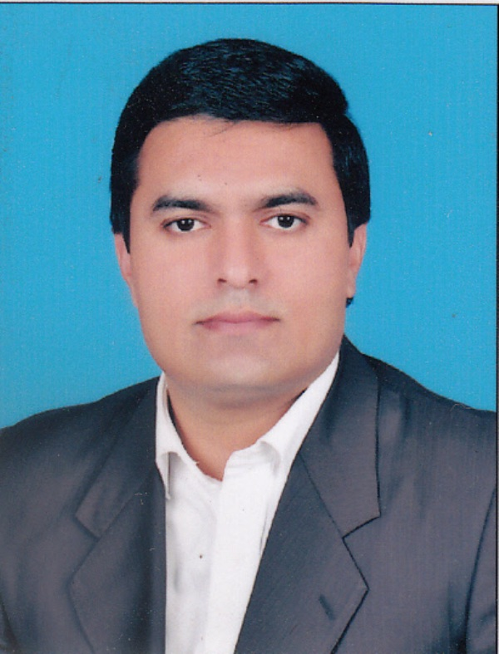
House No.62 Block A4 PGECHS Phase-1 College Road Township Lahore, Pakistan
Phone(s): 092-42-35189146, 092-321-4815966
E-mail: umarsaeed_pk@yahoo.com
Date of Birth: 11th September, 1981 Marital Status: Married

Career Objectives

To be the part of a dynamic and energetic institution team and utilize my competence, talent, skills and experience to contribute towards the institutional and professional excellence.

Experience

American Lycetuff International School System-Lahore Sep.2011 to date
Teaching Urdu and Islamiyat to Matric

Beaconhouse School System-Lahore Aug.2017 to Jan.2018
Have taught Urdu and Islamiyat to Matric

Naeem Shah Academy-Lahore Apr.2013 to date
Teaching Urdu to Matric and Intermediate

Home Tuitions-Lahore Nov.2008 to date
Giving home tuitions

Professionals Group of Academies-Lahore May.2008 to Aug.2010
Have taught the following subjects to mentioned levels:
- Matric: Urdu, Islamiyat, Pakistan Studies and Arts Subjects
- Intermediate: Urdu, Islamiyat, Pakistan Studies and Arts Subjects
- Graduation: Urdu, Islamiyat, Journalism, History, Arabic and Punjabi

Mobilink Franchise-Lahore 8 Months-2009
Worked as Operation Executive and got exposure on the following:
- Accounts operations, Marketing strategies, Customer interaction

Unilever Pakistan Limited-Lahore 6 Months-2008
Have done Assignments and Projects successfully during Internship:
- IMT (International Modern Trade)
- Merchandising, Plano gram, Ordering process and Consumer interaction
- GT (General Trade)
- Actively participated in the wholesale Dosti Loyalty Program

The City School Head Office-Lahore Dec.2004 to Nov.2005
Worked as Store Officer and my responsibilities were as under:
- Inventory management and Book Keeping (Inward/Outward)
- Coordination with the Head Office

Style Embroidery Services Providers-Lahore Oct.2000 to Jan.2003
Worked as Marketing Manager and my responsibilities were as under:
- Book keeping (Inward/Outward)
- Purchasing, Operations

Education & Qualification

University of Sargodha 2019
M.Ed. (In Progress)

University of the Punjab 2015
M.A Political Science: Marks 480

University of the Punjab 2014
B.Ed: Marks 673

University of the Punjab 2008
M.A Urdu: Marks 492

Premier College of Business Administration & Economics-Lahore 2004
MBA-IT: CGPA 3.21

University of the Punjab 2003
B.A: Marks 453

Premier College of Business Administration & Economics-Lahore 2003
BCS: CGPA 2.82

Punjab College of Commerce-Lahore 1999
I.Com: Marks 513

Govt. Model High School Model Town-Lahore 1997
Matric (Science): Marks 446

Computer Skills

Familiar with Microsoft Office Word, Excel, PowerPoint and other basic computer operations.

Hobbies & Interests

- Reading Books, Newspapers & Magazines
- Playing Cricket, Badminton & Football

References

References will be furnished on request.

