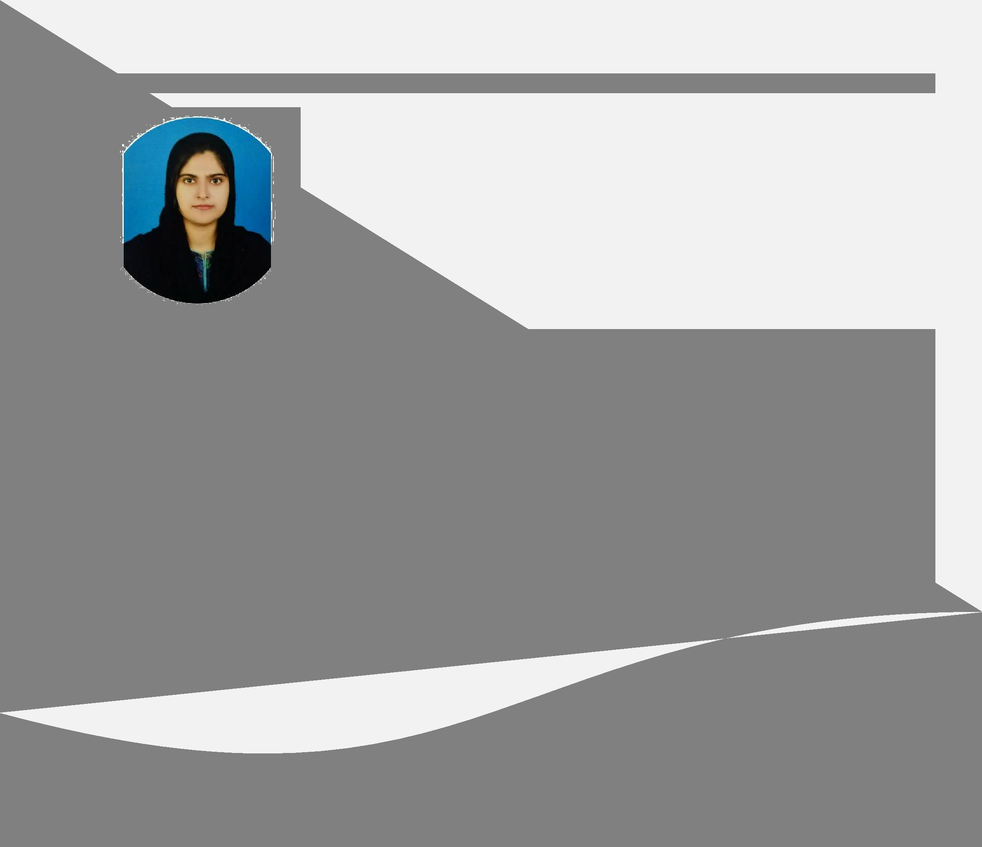
E -1 4 1 / 3 B, QADRI COLONY - 1, STREET - 3 WALTON ROAD LAHORE– 0333-3708587 / 0342-3545646 – asmaarbaig@yahoo.com

ASMAAR ASHRAF BAIG

A highly passionate and hardworking teacher seeking to obtain a position in high school that will allow me to use my strong passion to make a difference for student development coupled with skills and experience that will enable me to utilize my energetic attitude and instructional abilities to lead students.

- INFORMATION-

 | Father ‘s name | Muhammad Ashraf Baig
• | Date of Birth: | 10-09-1993
• | CNIC: | 45504-4187444-8
• | Nationality: | Pakistani
• | Religion: | Islam

- WORK EXPERIENCE -

High School Coordinator , Govt. Modern High School, Sukkur.

April-2018 – January-2019

- Took a prominent part managing the extra-curricular activities.

- Prepared students for debate competition.

- Responsible to maintain paper work before deadline.

- Had been a class teacher of standard 8.

High School Teacher, The Elegant Education Foundation School System, Karachi.

February-2017 – April-2018

- Taught mathematics to 6, 7 and 8 standards.

- Had been a class teacher of standard 7.

- Managing extra-curricular activities.

- Prepared result and report cards of students and handled parents very gently in PTM.

  - EDUCATION -
- 2018 – Master of Education (M.Ed.) – Allama Iqbal Open University.

- 2017 – Master of Science (M.Sc.) Mathematics – University of Karachi.

- 2015 – Bachelor of Education (B.Ed.) – Allama Iqbal Open University.

- 2013 – Bachelor of Science (B.Sc.) – Shah Abdul Latif University, Khairpur.

- 2011 – Intermediate – APWA High School, Sukkur.

- 2009 – Matriculation – APWA High School, Sukkur.
- SKILLS -

- Create a positive learning environment.

- People management.

- Confidence building.

- Results oriented.

- Management.

- Growth mindset.

- Problem Solving.
- MS OFFICE


- INTERESTS -

When I am not working, I enjoy reading books, spending time with my family and play badminton.

- REFERENCES -

Available on demand.

