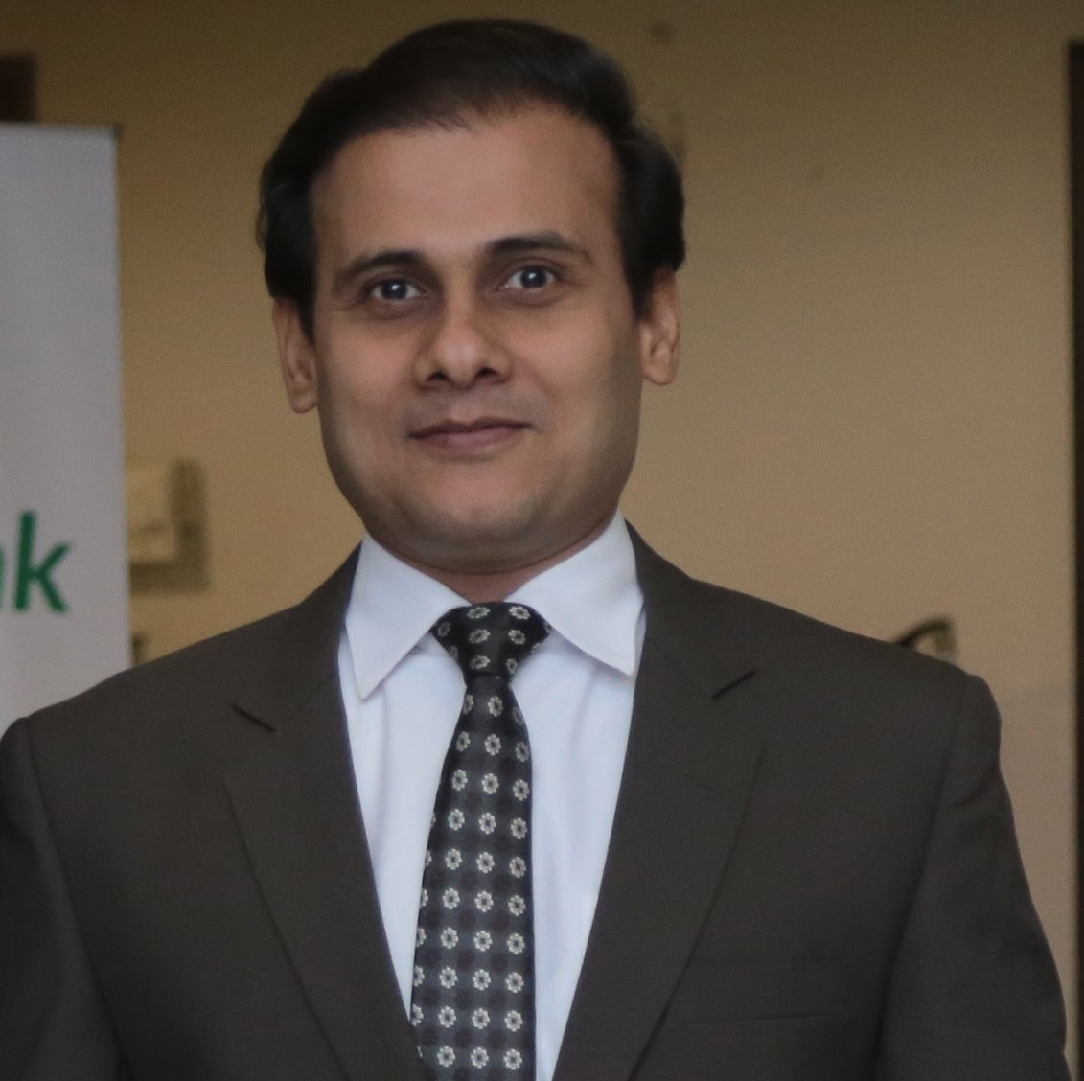
Kamran Aftab

Mobile No. 0300-2462190
Phone No. 34976198 – 34981975
E-mail: ahmadcamran@hotmail.com

Professional Profile:
A highly experienced personnel practitioner with a comprehensive and strategic understanding of HRM, business, technical issues, organizational change, supply chain logistics and management. Able to devise and implement coherent HR strategies whilst improving internal processes and procedures within a demanding environment, project deadlines and budgets.

Career Progression
Assistant Manager
IBA (Institute of Business Administration) Karachi, Pakistan April 2014 – Present

Key Duties & Responsibilities in IBA:
- Directs the needs assessment for training and staff development to enhance the effectiveness of employee performance for client specific programs
- Responsible for developing both open and client-specific business opportunities.
- Reviews evaluations of training courses, objectives and accomplishments
- Monitored training expense and budgets for respective departments
- Assisted IBA HR dept. to establish recruiting, and interviewing program for CEE dept. & counseling director on candidate’s selection.
- Assisting with the scheduling of training sessions and booking/notifying all relevant parties
- To provide administrative support to the CEE, coordinate with faculty and clients, and undertaking ground research for both open and client-specific programs.
- Assisting faculty in arranging Faculty and Business Interactive forums for courses design and market need assessments

Specialized Projects Supervised:
- Specialized training programs for different universities; KU, NED University, GCUF and many more to increase efficiency in processes and capacity building.(April – November 2014)
- World Bank funded Tertiary Education Support Program of Higher Education Institutions, to bring process efficiencies in management.
- Capacity building of Sindh Revenue Board commissioners

Executive
Axact Pvt Ltd Karachi, Pakistan October 2010 – April 2014

Key Duties & Responsibilities in Axact:
- Working with the senior team to insure achievement quantitative and qualitative goals
- Manage processes of departmental operations and functional units
- Establishing set of rules for product design process.
- Integrate and optimize all the steps required to produce the right quantity of the right product.

- Recommends training resources and communicates availability of resources to departmental heads
- Planning the inventory and managing its levels

Sales Executive
CityFM89 –Dawn Media Group Karachi, Pakistan Aug 2007 – Feb 2009

Key Duties & Responsibilities in CityFM89:
- To look after the direct clients.
- Interacting with Agencies like MCOM, Media Pulse, Bond Advertising, 5th Elements & with their clients.
- Designing the media plan.
- Managing the advertising staffs, creative, and media services departments.
- Maintains the accounts of clients.
- Evaluate advertising and promotion programs for compatibility.
- Exhibitions & Events Management for CityFM89 & Dawn News TV.
- Buying & negotiating with the vendors for promotional & complementary merchandise.
- Performing market research for listener-ship and reach.

Marketing & Services Executive
AFK Group Karachi, Pakistan July 2006 – July 2007

Key Duties & Responsibilities in AFK Group:
- Document risk assessments where relevant.
- Workforce planning.
- Conduct prompt investigation and reporting of accidents and implement remedial action.
- Employee recruitment, orientation, records management and retention strategies.
- Adherence to policies, procedures as well as laws and regulations.
- Advice and assistance on performance, compensation and benefit issues.
- Manage administrative matters to ensure that company maintains appropriate records necessary for legal and record keeping requirements.
- Training & Development
- Maintenance of office building, vehicles and record of fuels.
- Purchasing of all material related to office construction and auto parts for vehicle

Personal Info
Education & Qualification

M. B. A. PAF-Karachi Institute of Economics & Technology 2009
B.B. A. PAF-Karachi Institute of Economics & Technology 2006

Father’s Name: Aftab Ahmad Chaudhry
Address: C-16 K.D.A Officers housing society block “B” Gulshan e Iqbal. Karachi, Pakistan
Date of Birth: 29-01-1984
Marital Status: Married

References
- Syed Shakeel Ahmed Visiting Faculty-PGD IBA 0302-8228687
- Sheriyar Zardad Assistant Manager Axact 0333-0266659

