Hafiz Babar Hussain 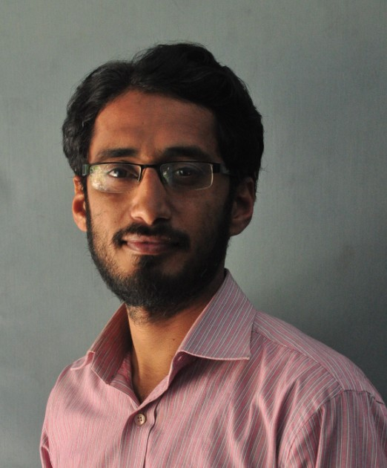
Muslim Colony, Kotli Behram City Sialkot.
Cell #: 0092-333-8653075 – Mob #: 0092-345-6734164

OBJECTIVES
Dormant Potential and creative activities flourish with mental solace and tranquility, it is but natural so I want to work in such a cerebral and congenial environment where I can groom and utilize my innovative, dedicated and dynamic skill for the development of organizational well-being.

PERSONAL INFORMATION
Full Name: Hafiz Babar Hussain
Father’s Name: Faqir Muhammad Chohan
Permanent Address: Bhanopindi, Jamkey Cheema Teh Daska,
Distt. Sialkot.
Date of Birth: 02-05-1978
N.I.C Number: 34601-0119041-7
Religion: Islam
Gender: Male
Nationality: Pakistani

WORK EXPERIENCE
• 15 years in Dar-e-Arqam Schools & College (Pakistan)
• As a teacher of Biology from April 2001 July 2003.
• As Principal from July 03 to March 2008
• As Dy. Director (edu) April 2008 to Dec 2014.
• As Executive Principal Feb 2015 to Feb 2016.
• 3 ½ years in Ghazali Schools (Pakistan)
• As a Managing Director from March 2016 to till date.

Key Achievements during Experience:
Proven professional ability to:
- Create and monitor policies and practices that promote a safe learning environment;
- ensure a school culture that encourages continuous improvements for teachers and student;
- develop an environment that encourages open communication with colleagues, students, and the community;
- mentor educators in the creation and implementation of class instruction, lesson plans, and student assessment.

Detailed educational knowledge and core skills include:
Student-Centered instruction/ Program Development/ Parental Involment/Attendance and Grade Reports/ Individual Educational Plans/ Curriculum Development and Implementation/ Co-curricular involment/ Training and Development/ Budgeting and Forecasting/ Team Building/ Educational Administration/ Classroom Management/ Instructional Programming.
Academics:
- Plan, control and direct the overall activities for secondary school with 1800 students and 120+ Staff members,
- Scope of position includes: staff requirement, development and evaluation;
- fiscal management; record administration organization and maintenance; student discipline;
- Program Initiatives; team building, shared decision making, school value promotion, advisory council coordination, and creation of a safe, respectful, and fair environment.
- Increased Student strength from 23 to 1800+
- Minimum students discipline rate.
- Increased student reading at grade level by implementing “home reading program”
- Stretched curriculum development function in all academic subjects to boost the quality of education.
- Created and led textbook review committee: reviewed, selected and purchased modern learning resources.
Professional Development:
Classroom management Literary Interest Development
Dimensions of Learning Leadership Skills
Discipline Management Team Building Techniques
Curriculum-21st Century Special needs Education
Motivation-make it work Kinetic Learning
Delegation Control Student-Centered learning
Finance:
Got Expertise in cost analysis, analyses of resource allocation, and cost-effectiveness and benefit-cost studies.
Can apply state-of-the-art methods to analysis of school finance policy and large-scale studies of resource allocation in School in the benefit of students and teachers, staff.

RESEARCH WORK
- “ORIGIN OF MAN” A booklet based on Quranic and Biological Studies
- “EDUCATION AND PHYSICAL PUNISHMENT” A book based on Techniques of teaching, historical objective of Education, Methods of teaching used in Past, Present and Future era.
(working on this Project)

PROFESSIONAL SKILLS
• Professional skills of writing (calligraphy)
• Fluent in English language.
• Have arranged 34 Teachers Training Workshops.
• Have delivered 73 lectures in Different Professional Programmes
and Seminars.

ACADEMIC CAREER

Certificate/Degree Year Institute Subjects Marks Obtained

M.A 2003 Punjab University Islamiyat 515/1000

B.Sc 2000 Punjab University Botany, Zoology 454/800

F.Sc. 1997 Board of Intermediate & Premedical 613/1100
Secondary Education

S.Sc 1995 Board of Intermediate & Science 687/850
Secondary Education

PROFESSIONAL QUALIFICATION
• B. Ed 2005

ADDITIONAL QUALIFICATION

• Hifz-e-Quran • N.C.C.

DISTINCTION
• Have shown Distinctive Results in Specified field.
• Best Administrator for the year of 2004-2005.
• Best Debater – District Sialkot.
• 1st and 2nd Prize in Calligraphy & Tilawat respectively (Teh. Daska)

COMPUTER EDUCATION
Diploma in Computer Sciences.
1 year

HOBBIES
Research, Consulting Library.

