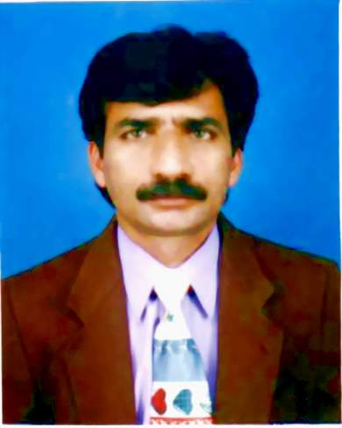
MUHAMMAD SALEEM MUSTAFA

CONTACT INFORMATION
- Permanent Address: House No. 08, Street No.
45-C, Madina Mohallah, Main Bazar No. 2, Ghaziabad, Lahore Cantt. | - Phone (Office): +92-42-37533045-46
 | - Cell: +92-301-4257137
- Office Address: Institute of Cost & Management Accountants of Pakistan (ICMA Pakistan),  42-Ferozepur Road, Lahore. | - E-mail: m.saleem@icmap.com.pk  alihajveri786@gmail.com
OBJECTIVE
My ambition is to become proficient in my Profession. Hard working, professionally committed, able to take initiative, can adjust in any kind of environment, strongly believe in teamwork, equipped with I.T. skills in pursuance of a career in Library Science Planning/ Scheduling Management.

PROFESSIONAL EXPERIENCES
Designation: Assistant Director
Duration: March 01, 2001 to Present.
Employer Name: ICMA Pakistan
Location: Lahore, Pakistan.

Designation: Libraian / Lecturer
Duration: January 1, 1994 to February 28, 2001.
Employer Name: Government College University.
Location: Lahore, Pakistan.

Designation: Principal
Duration: January , 1999 to February 2006.
Employer Name: The New Crescent Way High School
Location: Suleman Park, Ferozepur Road, Lahore

Designation: Principal
Duration: March , 2007 to June 2014.
Employer Name: Bala Dul Ilm School System
Location: Soling Road, Ghaziabad Lahore

APPRENTICESHIP.
“Quaid-e-Azam Library” Lahore from January , 1993 to December, 1993.
- Data entry using Computer Software.
- Books Classification.
- Cataloguing.
- Filing of Cataloging Cards.

Seminar and Conferences
Organization:  Topic:  Venure: | Pakistan Library Assosciation (Punjab Branch)  Emerging Paradigm in Librarianship: A Call for Innovation  Aiwan-e-Ibal Complex, Lahore
Organization:  Topic:  Venure: | Pakistan Library Assosciation (Federal Branch)  Role of Libraries in Creating a Knowledge Society  Islamic University, Islamabad
Organization:  Topic:  Venure: | PEACE Learning Resource (Karachi)  Conference on Professional Enrichment of Best Performance  Pearl Continental Hotel, Lahore

ROFESSIONAL EDUCATION
EDUCATION  Result Declaration Date:  University/ Board: | Masters in Library and Information Science  1993  University of the Punjab, Lahore.
EDUCATION  Result Declaration Date:  University/ Board: | Englsh Language Course  2008  Kipling Centre, Lahore
ACADEMIC EDUCATION
EDUCATION  Result Declaration Date:  University/ Board:  EDUCATION  Result Declaration Date:  University/ Board:  EDUCATION  Result Declaration Date:  University/ Board: | Graduation (BSc.)  1990  University of the Punjab, Lahorte  Major Subjects: Math (A+B) Course,; Statistics.  Intermediate (FSc.)  1986  B.I.S.E., Lahore, Pakistan  Major Subjects: Physics, Chemistry & Mathematics  Matriculation.  1983  B.I.S.E., Lahore, Pakistan.  Major Subjects: Science

COURSE SECTION
Course Name:  Institution Name:  Location:  Week (Duration) | Microsoft Office  PLA,  Lahore, Pakistan  4 Months
COMPUTER PROFESSIONAL SKILLS
Operating system : Windows 7, Win XP, Win 9X, Win 2000 Professional.
Tools : Ms. Word, Ms. Excel, Ms. Power Point, Corel Draw, Adobe Photoshop, Inpage2008 and Internet.
Library Tools : KOHA3 (Library Integrated System), DSpace, MARC Editor, End Note, Library Management System (LMS), Library Information Management System (LIMS), Library Automation Management Program (LAMP), Oracle Library System
PERSONNEL SKILLS & CHARACTERISTICS
- Engaging Personality and Teaching Style
- Good Classroom Management Skills
- Good Coomuniaction with Students and Parents
- Clear Objectives for Lessons
- Effective Discipline Skills
- Knowledge of Curriculm and Standards
- Passion for Students and Teaching
- High Expectations
- Trustworthy.
- Positive Attitude.
- Ability to motivate myself and team members to achieve the overall organizational goals and assigned tasks.
- Take positive criticism well.
- Excellent multitasking, interpersonal and good time management.
- Good verbal communication skills.
- Strong partnering skills.
- Listening / probing skills help users clarify needs.
- Good Written and reasonable Verbal communication skills.
PERSONAL INFORMATION
Father’s Name | Muhammad Hanif.
Nationality | Pakistani by Birth.
Date of Birth  Religion | December 25, 1968  Islam
CNIC | 35201-2321410-5
Domicile | Lahore (Punjab), Pakistan.
Marital Status | Married

