RESUME (CV)
MUHAMMAD FAISAL SHAHZAD

PARTICULARS
Domicile: Sheikhupura (Punjab)
Date of Birth: 27-06-1980

PERMANENT ADDRESS | 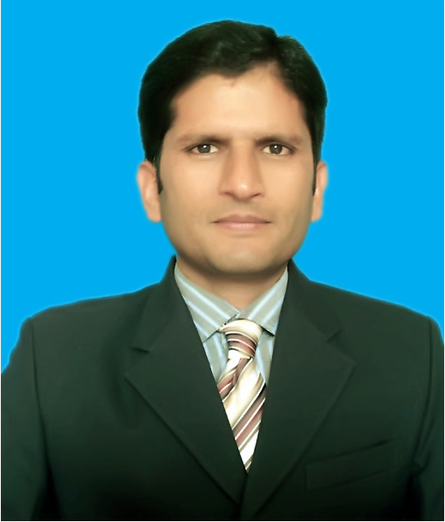
Mohallah Ahmad Pura, Behki Road,
Street Syeddan, Near Toor Aatta Store, House # 1, Sheikhupura
FAST CONTACT
Personal : 0341-6560786
Home : 0335-6560786
Email : faisal.toor786@gmail.com

OBJECTIVE
My objective of life is to use my skills and potential to assist an organization in achieving its goals which seeking long term career with optimum growth. This objective would be supported by my Certifications, Courses, Training, and English communication & writing skills.

EDUCATION
Degree/  Certificate | Institute | Passing  Year | Marks  Obtained | Total  Marks | Div/grade
MBA (HRM) | Virtual University (VU) | 2014 | 2.40 | 4.00 | 1st
B.A (Economics) | Punjab University (PU) | 2009 | 447 | 800 | 2nd
F.Sc (Pre-  Engineering) | Govt. College (GC)  Sheikhupura | 2003 | 494 | 1100 | D
Matric (Science) | Govt. High School  Sheikhupura | 1999 | 581 | 850 | 1st
B.Ed (Arts) | Allama Iqbal Open University | 2013 | 593 | 900 | 1st

CERTIFICATION/ COURSES
Call Center / Communication Skills
Smart Communication Institute, Lahore: Call Center Training Course in English with American and England Accent: (10 June, 2009 – 15 July, 2009)
Job Experiences
Facilitation Assistant at Sialkot Int. Airport (Continue)
Assistant Manager Admin. at Micro Inn SKP. (3 Years) &
Customer Service Rep. (Call Center) (1 Year)
- Currently working at Sialkot International Airport as Assistant Facilitations (Customer Services) from (9th-Jul-2018)
- Micro Inn Technologies (Sheikhupura): Assistant Manager Admin: (July 05, 2010 – August 10 2013)
- Smart Communication (Lahore): Customer Service Representative: (June 10, 2008 – July 15, 2009)

IT / COMPUTER TRAINING
Punjab IT Board (PITB), Basic Computer Training Course, 3 months duration, MS Word, Excel, Access and Internet skills (09 Dec, 2006 – 22 Dec, 2006)

CIVIL DEFENSE TRAINING (NCC)
GC College Sheikhupura, National Cadet Core (NCC), One month and ten days duration, Pakistan Army
(20 Feb, 1998 – 20 Mar, 1999)

COMPUTER SKILLS
- MS Word (Word, Excel, PowerPoint, Access) & Internet
- Typing (40 Word/Min)
- Team players with excellent interpersonal skills
- Knowledge and use of information technology
- Strong analytical and problem solving skills, Communication Skills

BUSINESS / MANAGEMENT SKILS
- Accounting
- Banking
- Management

BUSINESS COURSES
- Economics
- Money and Banking
- Human Resource Management
- Business Communication

EXTRACURRICULAR ACTIVITIES
Gardening, Jogging, Painting (Oil & Water color medium), and Calligraphy

READING INTERESTS
Accounting, Economics, Computer, History, Religion, Mathematics, General Knowledge etc

