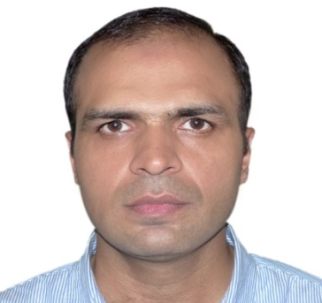
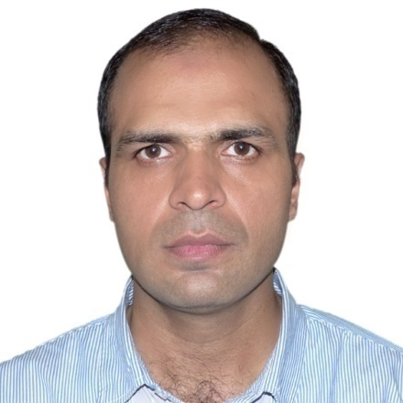
MUHAMMAD KHURRAM AZAD

CURICULUM VITAE

PROFILE
To obtain a position that will allow me to utilize my technical, along with my creative, problem solving skills and willingness to learn in making and organization successful. I possess strong working knowledge of Microsoft excel.

EDUCATION
- Masters in Education (Med) University of Sargodha (2013).
- Bachelor of Art (B.A)
University of the Punjab. (2008)
- Diploma of Associate Engineering (D.A.E). Punjab board of Technical Education Lahore. (2002)
- Metric ( SSC)
Boar of intermediate and secondary education Lahore. (1998)

Diploma of Associate: Punjab board of technical Education.
Bachelor of Arts: University of the Punjab

- 3 month certification in Event Management arranged by Expo center Lahore.
- 3 month certification in sales and marketing arranged by Expo center Lahore.
- 6 month certification in merchandizing technique arranged by Punjab skill development funded by city and guild UK.

Address
House No. 22 Jade Park View Villas Main Mulatan Road Lahore.

Phone
0333-4955774

E-Mail
khurramazadpk@gmail.com

CERTIFICATIONS
CONTACT
- 13 years of experience in the field of maintenance supervision and technical training.
- Expertise in manage and resolve the management issues in the system by approaching the consumers.
- Technical teaching experience
- Expertise in design and implementation system to improve overall efficiency of organization.
- Good relationships management and negotiation skills in liaising consumers.

EXPERIENCE

