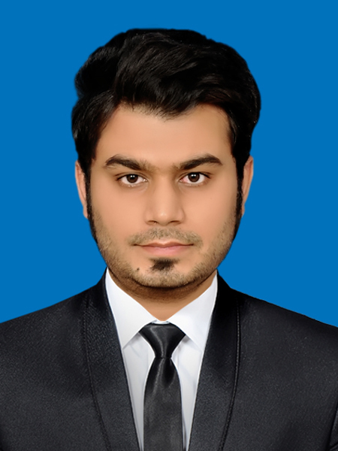
FAIZAN ASGAR

Address : House 1268, Dastagir Dawa Khana Lakkar Mandi Faizi Road,
Multan
Phone : 03333650909 | 03004967944| Email : Faizan_leo@yahoo.com |
Skype: fazzy126

Career Objective
Hard-working with proven leadership and organizational skills, and minute attention to detail. Seeking to apply my abilities to fill the important role in your company. I am a dedicated team player
who can be relied upon to help your company achieve its goals.

Education

January 2009 – February 2013
The University Of Lahore
Bachelor Of Technology, B. Tech (Honours) In Electrical
Percentage: 73%

University Of The Punjab Lahore. 2011
Bachelor Of Arts, B.A (Economics)
Percentage: 50%

Punjab Board Of Technical Education Lahore. 2003 - 2006
Diploma Of Associate Engineer, DAE In Electrical Technology.
Percentage: 70%

Board Of Intermediate And Secondary Education Multan. 2003
Matriculation In Science
Percentage: 58%

Work Experience

(2) April 2013-October 2015
Gulf Engineering Services Multan
(worked as Electrical technician)

worked in different projects like Uch power plant, AES Lalpir
power plant. this work was composed on repair and maintenance and overhauling of electrical Equipment AC and DC motors, generators, blower motors. Maintaining lighting system, and power supplies.
laying of 3 phase cables from transformer to panels and further electrical equipment like motors, lighting System, installed machines. protection system like circuit breakers, relays and using receptical switches Also installed cctv cameras and dvr with different channels.

My approach:
I would like to derive professional satisfaction by helping others
Computer Literacy
- Microsoft office, excel, word, power point, presentation
- Familiar with statistics and mathematics package and Implementation Of Software
- Operating system, windows 7, 8 and 10
- Computer hardware and software, trouble shooting

Skills
- Energetic graduate and performer
- Assessment and Feedback
- Professional Development
- Conflict Resolution
- Scheme of Work
- Challenging Learners
- Relationship Building
- Resource Development
- Team Leader
- Administration
- Focus on accuracy
- Positive attitude
- Deal effectively to number of tasks

Computer Course
Course Name: computer applications & software
Institute name : Zakariya college of commerce & computer science
multan
Duration: 21/05/2007 to 22/08/ 2007
Status: completed

Personal Information
Father’s Name :- Doctor Asgar Ali Azher
Date Of Birth :- 05thSeptember 1987
Nationality :- Pakistani
Marital Status :- Single
Religion :- Islam
Contact :- 03333650909
CNIC No :- 36302-7825665-3
Passport Id :- AL1826653
Address :- House No 1268, Dastagir Dawa Khana
Lakkar Mandi Faizi Road, Multan

References
Available upon request
Operating system, software
Photoshop
Troubleshooting
Communication

Language Proficiency
- English
- Urdu
- Punjabi

Hobbies
- Reading
- Listening to music
- Travelling
- Kayaking
- Watching films
- Play Cricket and football
- Spending time with family and friends

Other Skills
MS office

