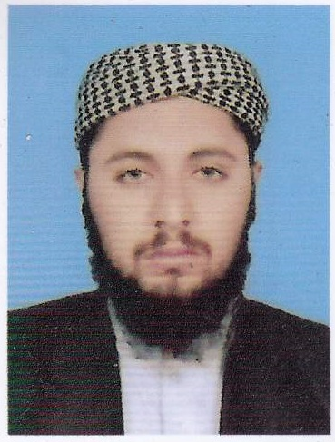
IJAZ AHMAD
House no. 223, Nishtar Block, Allama Iqbal Town, Lahore
Cell #: 0346-9544358

OBJECTIVE:

To proceed a challenging career in your esteemed and prestigious organization and go to professionally and need an opportunity to employ, my skills, knowledge, time, and energies for your organization.

PERSONAL DETAILS:

- Father’s Name : Muhammad Iqbal
- Date of Birth : 10-02-1993
- Marital Status : Single
- Religion : Islam
- Gender : Male
- CNIC # : 15601-2922351-9
- Domicil : Lahore

ACADEMIC QUALIFICATION:

DEGREE | INSTITUTE/BOARD
Matric (Science) | BISE SWAT
F.Sc (Pre Medical) | BISE SWAT
B.A | University Of Swat
M.A | University Of Swat
M Phill | Punjab University (Continues)
Dars-e-Nizami | Jamia Ashrafia Lahore

SKILL

- MS Office
- Internet Browsing

EXPERIENCE

- One Year Experience Of Teaching At Swat.

STRENGTH:

- Regular & Punctual Hardworking, Good Communication, Self-Motivated
- Quick Liner

REFERENCE:

Will be furnished on demand.

