MUHAMMAD TAHIR  H#49 St#13 Mujahidabad (Ramgarh) Moghalpura, Lahore  Cell# 0324-4533453 & 03334456381 Res: 042-36842022  Emails: mtahir36@gmail.com | 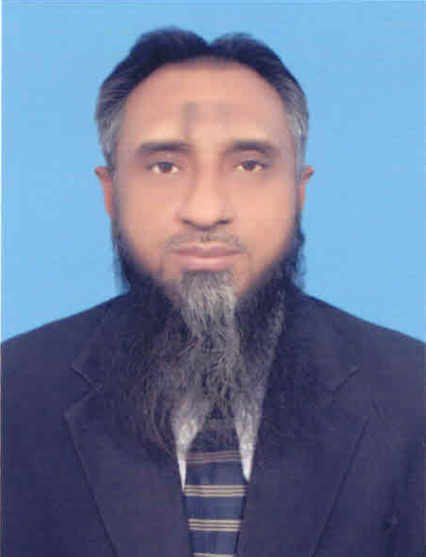

CAREER OBJECTIVES
- Looking forward to apply acquired teaching skills and facilitate the student interests in the area of Computer Sciences, English & Mathematics and HRM.

Work Experience:
- Principal:

- Al-Mustafa Academy of Arts & Sciences as Principal for about 06 years 1990 to 1996.
- Used to get the designed lessons as Principal from teachers for the students.
- Gave individual attention to students for improper school results.
- Provide a monthly written report to the school board on the progress of the class at the end of each month.

- Chief Organizer:

- Suffah-o-Basriah School System (a NGO) as Chief Organizer and reliever teacher for about 5½ years Dec 2000 to June 2005.
- Overall administration of educational and healthcare institutes working under a Trust
- New Systems Development
- Formulating & implementing SOPs
- Overseeing recruitment, selection, training & development
- Vice Principal/ HR Manager:

- Ittefaq Superior High School (English Medium) Girls Campus (an NGO) as HR Manager /Vice-Principal. Sr. Teacher of Computer / Mathematics/ English about 1 year Nov 2017 to Dec 2018.
- Having teaching experience of Computer Sciences, English & Mathematics
- Having experience of Administration & Fee Collection

Educational  Qualification: | - MBA (HRM) 2 Yrs. University of Veterinary & Animal Science (Govt. University)  - MCS 2 Yrs. Al-Khair University, AJK (HEC Recognized)
Professional Qualification: | i. MCSE, Linux & CCNA 3 M (Corvit Systems)  iv. DCS 1 Y (PETROMAN)  v. Oracle-7 3 M (UET Lahore)  vi. Business Eng. 2 M Pakistan Institute of Management (PIM)
Personal Info: |  | - Status - Married (widower) with sound health.
Expected Salary |  | - Any suitable - Market oriented
References: |  | - May be provided on demand.

Muhammad Tahir

