MUHAMMAD ASAD 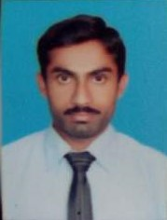 (MSc. Zoology) Cell:0346-8452313 0324-9703066 Email: captainpk12@gmail.com Adress: Mohallah Jahangir park near General Hospital,Lahore
Permanent Adress: ,Malakwal Distt. M.B.Din
PROFILE:
I love to work with hardworking teammates and also interested to expand my abilities. I want to be a person which I needed the most at my student age. I believe that we should prepare the students both for exams and as well as for the ups and downs of life.
OBJETIVE:
I am seeking an opportunity to become a part of competitive staff and a well established institute, to be more professional and effective in my field of work.
PERSONAL INFO RMATION:
Name. Muhammad Asad
Father’s Name Mirza Khan
Date of birth 14-08-1996
Gender Male
Nationality Pakistani
CNIC # 34401-5860302-1
Marital status Single
QUILIFICATION:
M.sc
Major- Zoology (2019) University of The Punjab, Lahore.
Marks- 745/1200
B.sc
Major- Zoology-Botany- Chem (2017) University of The Punjab, Lahore.
Marks- 474/800
F.sc
Major- Biology (2015) B.I.S.E Gujranwala.
Marks- 825/1100
Matric
Major- Science (2013) B.I.S.E Gujranwala.
Marks- 853/1050
Professional Experience:
1 year for F.sc and Matric at QSCA Lahore.

