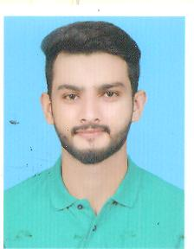Wajih-ul-Hassan
  Date of birth: 26 september,1996
  Contact
  Tel : 0092-332-4844581
  e-mail : stylish.masi@gmail.com
Address
House#A-10 Wapda Head Office Staff Colony Shalimar Town Lahore, Pakistan.

Profile
Objective | Keen to work in any national or multinational organization having potential for making a good future and to make a good name in every field of life. I want to obtain a managerial level position within a dynamic organization. To work in competitive and challenging environment. I wish to meliorate my skills at high level.

Key Skills
Proficient or familiar with a vast array of computer programs and software, concepts and technologies, including:
Computer Applications | Computer Languages | Windows | Internet
Word, Excel, Power Point, Access | C,C++,HTML, JavaScript, CSS, Bootstrap | XP2007, Windows 7,Windows 10 | Outlook, Firefox, Ask,  E Buddy, Opera

Experience
Teaching for 3 years in academy.
2-month internship at BNU as front end developer.

Education and Certifications
2010 to 2012 | Matriculation in science  Math, Physics, Computer, Chemistry
2013 to 2015 | Intermediate in computer sciences  Math, Physics, Computer
2017 to 2019 | Associate Degree in Information Technology Continued
Microsoft Office Specialist  Microsoft Office Certified | MS Word , MS Power Point , MS Excel  MS Word

Activities and Interests
Internet | Browsing informative stuff. Wikipedia. Google. Ask.
Automobile | Cars in general, sports cars.
Traveling  Coding  Reading | Pakistan, Australia, Iraq ,UAE  To Do Computer Programming.  Reading books ,Newspaper

Languages
English (Fluent) | Urdu (Fluent) | Punjabi (Fluent) Saraiki(Fluent)

