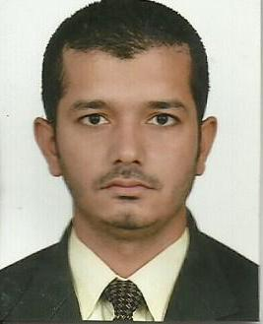
urriculum
itae
SOHAIL GHANI
: Ayesha Mansion flatno.6 gao gali khadda Market
: 00971552310948 / 00923045599667

Objective:

✓ Looking for a bright and long-term career in a reputed organization to
Refresh my previous experience and to do something valuable to the
Organization.

Qualification:

- (Matriculation) from Board of Karachi.
- (Intermediate) from Board of Intermediate Karachi.
- (Graduation) from university of Karachi.

Job Experience:

- Two Years Experienced as a (CLERK) from, 2008 to 2010 with,
- (KARACHI INTERNATIONAL CONTAINER TERMINAL.)

- Two Years Experienced as a (OFFICE CLERK) from, 2012 to 2014 with,
- (Target Engineering Construction Company)
- Abu Dhabi (U.A.E)

- One year Experience as a (Messenger Office Assistant) with,
- Integrated Gas Services Member of Sergas Group Shahrjah U.A.E.

Computer Skills:

- Microsoft Office Course from (K.M.A) Institute of Information
- Technology Karachi.
- Microsoft Word
- Microsoft Excel
- Microsoft Power Point and Internet Email etc.

Personal information:

 Father’s Name : Abdul Ghani
 Date of Birth : 27.07.1987
 Marital Status : Single
 Nationality : Pakistani
 Domiciles P.R.C : South Karachi
 Religion : Islam
 C.N.I.C : 42301-5021128-1
 Emirates ID : 789-1987-0943659-0
 Passport No. : CV-4111282 Exp. (2023)

Languages

 English, Arabic, Urdu.

Reference:

 Will be furnished upon request

