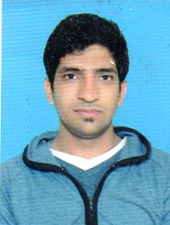

Asif Aziz

House # 87 St # 1. Shah-Di-Khui Dhana Singh New Campus Lahore

Cell #03224944043

Email Address:asifaziz426@gmail.com

Career Objective ►

To apply my skills in a challenging and dynamic environment that fosters & reward, positive attitudes pro-active work style and shared goals, to be the part of team that want to make the difference and is driven by the “will to succeed.

Personal Information ►

Father’ Name Muhammad Ashraf
D.O.B 06-04-1994
N.I.C 35202-1735747-1
Religion Islam
Marital Status Single
Nationality: Pakistani

Educational Qualifications ►

Qualification | Year | Institute/Board
BS English | 2014-18 | Govt-College Of Science
Intermediate | 2014 | Lahore Board
Matriculation | 2012 | Lahore Board

Working Experience ►

- 2 Years Home Tuition
- 6 Months Academy
- 3 Months PTCL call centre

Hobbies ►

- Cricket
- Islamic Literature Reading

Reference ►

- Will be furnished on demand.

