Sobia Siddique
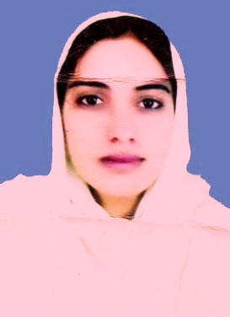
Cell # 0300-6312309:0345-4446748
E-mail: sobiasiddique44@gmail.com
Current Address: D Block no.38, Lane no.18,House no.1, Wafaqi colony Johar Town, Lahore.

Objectives

To work at a challenging post in a reputed organization with professional working environment and opportunities to gain professional growth.

Personal Information

Daughter of Muhammad Siddique
National ID card No. 34502-4999731-6
Date of Birth 28-12-1985
Marital Status Married
Domicile Narowal
Languages Urdu, English, Punjabi, Saraiki

Professional Working Exposure

- 2 years job experience as CTI of library and information Science in Government College Mankera (Bhakkar).
- 3 years job experience as librarian at Punjab College Gujranwala
- 2 month internship at FAST National University ,Lahore

Academic Qualification

Degree | Years | Board/university | Division | Marks
M.Phil | 2019 | University of the Punjab | 1st | 3.48CGPA
MLIS | 2008 | University of the Punjab | 1st | 3.60CGPA
BA | 2006 | University of the Punjab | 1st | 495/800
FA | 2004 | Gujranwala Board | 1st | 746/1100
Matriculation(science) | 2002 | Gujranwala Board | 1st | 672/850

Professional Skills

Hard skills
- Endnote
- Calibre
- Mandely
- Zotero
- SPSS
- Koha
- DSpace
- MLims
- Latest searching techniques

Soft skills
- Good communication
- Time management
- Leadership
- Interpersonal skills

Achievements

- Merit scholarship During MLIS and MPhill.
- Attended one day workshop on linked data technology and Digital Libraries
- Attended 3 day international conference on Librarianship
- Diploma in spoken English
- Attended 2 days workshop on Koha Open Source Software.
Computer Literacy

Good knowledge of Microsoft Office .
Good command on databases searching.

References

Reference will be furnished on request.

