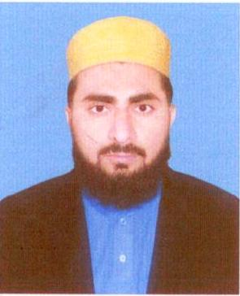
GHULAM MURTAZA
Main Bazar Raokhanwala Near Railway Station,
P/O Khas, Tehsil & District Kasur.
Cell: 0306-4717395, Email:ghulammurtazarkw@gmail.com

OBJECTIVE
To enhance my knowledge, improve my skills and pursue a dynamic career, where I can meet challenges and brain storms.
PERSONAL INFORMATION
- Father Name Rehmat Ali
- Date of Birth 01-04-1988
- NIC No. 35102-9976032-7
- Nationality Pakistani
- Domicile Kasur
- Marital Status Unmarried
- Religion Islam
QUALIFICATION
- Matriculation (Science) Lahore Board 2007
- Intermediate (I.C.S) Lahore Board 2009
- B.A University of Punjab 2014
- M.A (Islamic Studies) University of Punjab 2016

DARSE NAZAMI QUALIFICATION
From Tanzimul Madaris Lahore
- Shahadat-ul-Sanvia-Tul-Aama (Matric) 2013
- Shahadat-ul-Sanvia-Tul-Khasa (F.A) 2015
- Shahadat-ul-Alia (B.A) 2017
- Shahadat-ul-Aalmia Fil Uloom-Ul-Arabia Wal Islamia (M.A) 2018

COMPUTER EDUCATION
- DOM (Diploma of Office Management)

EXPERIENCE
- 5 years experience as Teacher at Al-Noor Public School, Teh Sheikhum, and District Kasur.
- 2 years experience as EST Teacher at GES Rao Khan Wala, District Kasur

REFERENCE
- Will Be Provided on Demand.

