Mailing Address: Street wakala near Hazrat Bilal Masjid near Amin
Colony Choke Kohat Road Peshawar
Cell: 03149096076
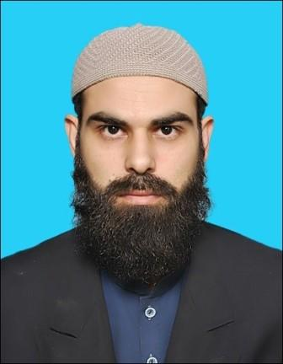

Applicant: Irfan Khan
Father Name: Abdul Rasheed
CNIC: 17301-5633571-7
Religion: Islam
Nationality: Pakistan
Date of Birth: 06-16-1985
Email: irfan.imstudies@gmail.com

My Education
Sr.# | Certification / Degree | Institution / University | Passing Year | Grade / GPA
1 | MBA(Finance) | University of Peshawar | 2012 | 3.7/4.0
2 | BSC (Hons) Economics | University of Peshawar | 2009 | 3.7/4.0
3 | FSc (Pre-Medical) | Government College Peshawar | 2005 | A
4 | Additional Mathematics | BISEP | 2004 | B
5 | Matriculation | HSSC Cantt No. 1 Peshawar | 2002 | A

Work Experience & Skills (Internee)

- I am a teacher in Alblagh model school Peshawar.
- I worked as a teacher in Tabeer Model School Civil colony kohat Road Peshawar from November,
- 2018 to April, 2019.
- I Worked as Trainee in A-Salam Jan & Co Firm (Chartered Accountants) from November, 2012 to October, 2013
- MS office
- Internet

My Hobbies

- Reading Newspapers, Books
- Playing cricket, Hockey, Football

Languages

- English, Urdu & Pashto (Read, Write, Speak)

References

It will be furnished on demand.

