NAVEED SULEMAN 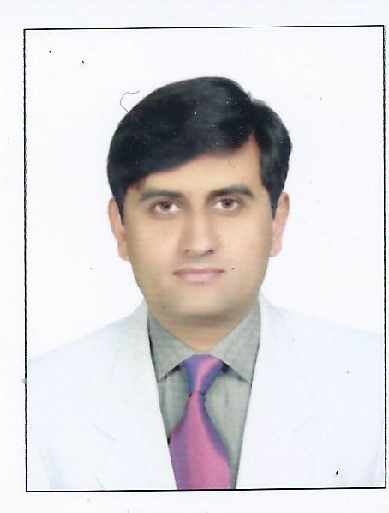
Postal address: 1) Allama Iqbal Town, Lahore.
Email: naveed_suleman20@yahoo.com; naveedEDX2018@gmail.com
Cell: (092) 0333-9160859

OBJECTIVES/APPLICATION FOR

I want to teach Biology and Chemistry to O-level /F.Sc./matric students. Also willing to teach entry test coaching classes for the ETEA/MDCAT etc.

DEMOGRAPHICS

Father name: Dr.Muhammad Suleman
Date of Birth: 04/09/1983
Marital Status: Single
Religion: Islam
Nationality: Pakistan
Domicile: Abbottabad
NIC no. 17301-6980814-1

EDUCATION

DEGREE | INSTITUTION | YEAR | PERCENT/GRADES
Ph.D  Pharmacology | University of Health Sciences (UHS), Lahore | In progress | In progress
M.Phil. pharmacology | University of Health Sciences (UHS), Lahore. | 2016 | 65.25%
Pharm-D | University of Peshawar | 2009 | 63.56%
F.Sc(Pre-medical) | Islamia College, Peshawar | 2002 | 77.91%
SSC(Science) | UPS, Peshawar | 2000 | 84.35%

PROFESSIONAL EXPERIENCES

- Worked as a ‘Hospital Pharmacist’ in the Main pharmacy of Rehman Medical Institute (RMI), Peshawar from Jan 15th to Sept 25th, 2009 (8 months). HOSPITAL PHARMACY

- Worked as a Medical Services Executive (MSE), in the sales Department of Glaxosmithkline Pakistan, Ltd. from Oct 11th, 2009 to Nov 16th, 2010 (13 months). INDUSTRIAL PHARMACY

- Worked as a PHARMACIST at Vikor Enterprises (Distributors) private Limited, Abbottabad from Sept. 1st, 2015 to Sept. 1, 2017 (2 years). INDUSTRIAL PHARMACY

- Worked as a lecturer in Udhyana Institute of Information Technology, Abbottabad for 1 year i.e., 04-01-2016 to 30-12-2016 (1 year). TEACHING

- Working as a “Research Associate” at Pharmacy Department, Comsats Institute of Information technology, Abbottabad from August 25th, 2011 till date (7 yrs). TEACHING

- Teaching of Chemistry and biology to F.Sc students for around 6 months (Home Tuition) in 2019 near my home. (TEACHING)

PUBLICATIONS

- Association of genetic polymorphism of CYP1A2 and CYP2C19 with the toxicity of leflunomide with rheumatoid arthritis patients. (Submitted).

- Response of Tramadol in Hepatocellular Carcinoma Patients in Associationwith Cytochrome P450 2D6*3 and 2D6*4 Genes Polymorphism (submitted).

OTHER FORMAL TRAINING OR EDUCATION / CONFERENCES

S# | Conference | Place | From | To
1 | 3 months clinical fellowship in medical unit of Hayatabad Medical Complex, Peshawar. | HMC, Hayatabad, Peshawar | 10-11-2008 | 10-01-2009
2 | Initial training course (ITC) GSK  (1 month) | PC Hotel Karachi | 11-08-2009 | 07-11-2009
3 | Breakthrough Performance A 1-Day experience | PC Hotel Karachi | 22-10-2009 | 22-10-2009
4 | GSK spirit session | PC hotel Karachi | 05-11-2009 | 05-11-2009
5 | Seminar on Awareness of Breast Cancer in Pakistan | University of Health Sciences, Lahore | 09-10-2013 | 09-10-2013

TECHNICAL LABORATORY SKILLS:

- POLYMERASE CHAIN REACTIONS: I have sound practical and theoretical knowledge of Polymerase Chain Reaction (PCR), Gel electrophoresis, DNA extraction by kit as well as by chloroform method, RFLP (Restriction Fragment Length polymorphism), Primer designing by using Primer3 software. I have made
buffer solutions personally for DNA extractions. I have very sound practical
knowledge of PCR trouble shooting and primer optimization. I have used
nanodrop for the DNA quantification personally. I have also used autoclave, and
Gel doc system.

- ORGAN BATH AND KYMOGRAPH: Organ bath, kymograph, power lab usage and preparation of related solutions.

- SEPARATION METHODS: Thin layer chromatography, Column chromatography, rotary evaporator, condenser, distillation procedures, maceration, decoction, percolation, preparation of different aqueous and alcoholic plant extracts. Also used spectrophotometer.

- MISCELLANEOUS: Other laboratory techniques including centrifugation, filtration, ESR, Hb count of RBC, Blood group testing, Blood coagulation time and bleeding time measurement, etc.

LANGUAGES

English, Urdu, Pashto, Hindko & Punjabi.

COMPUTER SKILLS

- MS Office
- Internet Surfing
- Database Oracle 10g.

REFERENCES

- Prof. Dr. Fazl Subhan, Department of Pharmacy, university of Peshawar. Email: fazal_subhan@upesh.edu.pk, Phone: 092-091-9216750,
Cell: 092-0301-8805966.

- Prof. Dr. M. Saeed, Chairman Department of Pharmacy, University of Peshawar, Pakistan. Email: saeedrph2000@yahoo.com. Phone: 092-0323-2175686.
- Mr. Fayyaz Niazi, Medical Services Executive, Hospital team, Glaxosmithkline Pakistan Ltd, Islamabad. Phone: 0321-9942580,
0322-5164139.
- Dr. Muhammad Shahzad, Associate Professor & Head Department of Pharmacology, University of Health Sciences, Lahore-Pakistan 54600. Tel Office: +9299231304-9 (ext 360), Cell: +923346061838 Email: shahzad912@hotmail.com
http://www.uhs.edu.pk/academics/pharmacology

