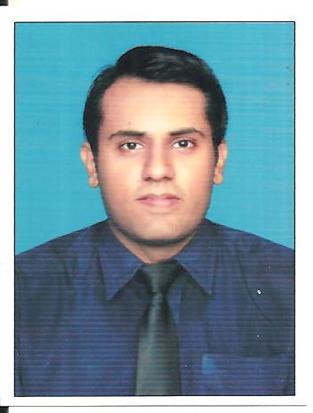 | Fahad Ijaz Malik  Address: 199-V Phase 2 DHA Lahore  Cell: 0322-4115356  Email: fahadmalik0322@gmail.com
Objective | To effectively acquired my knowledge and practical application in an affable working environment, with an ability to work on own initiative as well as a part of the team, with a commitment to succeed for the uplift of the organizational Goal...!
Education & Qualification | Government College University Lahore  MS Electrical Engineering (2016 – present)  University of Management and Technology (UMT), Lahore  BS Electrical Engineering (Nov 2013)  Garrison Academy For Boys Lahore, Cantt  A-LEVELS ( 2009)  O-LEVEL ( 2007)
Professional Experience | Learners Academy DHA Lahore  Mathematics Teacher ( O & A level)  Allied School System  Mathematics Teacher  M R Consultants Lahore  Internship
Final Project | - Driving Single Phase Motor With H-Bridge Inverter
Projects | - Designed Buck-Boost converter by using PWM (plus width modulation) technique  - Simulated 4-bit Counter on FPGA (Field Programmable Gate Array) by using Xilinx software
Computer Skills | - Lab view, MATLAB, Proteus ,Xilinx  - Microsoft Office (Word, Power Point, Excel)
Achievements | - Got certificate in IEEE brain clash quiz competition in 2013  - Cleared IELTS in 2006 (6.0 band)
Interests | - Teaching and Reading books, Creative-writing, Video games, sports

