CURRICULUM VITAE

MUHAMMAD JAMSHAID JAVED
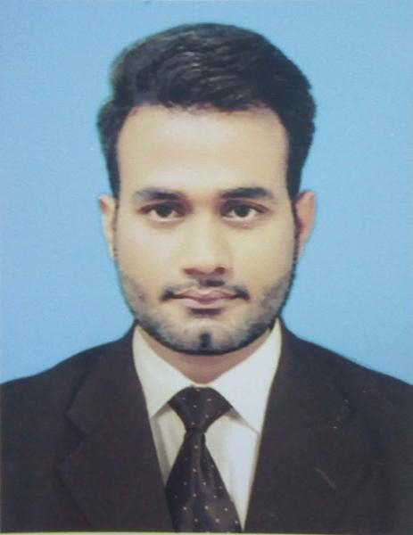
S/O: Muhammad Javed Aasi

Address:Yadgar Sadiq Mension 15 Noor Shah Road Mozang Lahore.

Current City: Lahore

Home Town: Sadiqabad

Marital Status: Single

Gender: Male

Contact Number:+923124293432

Email:jamshaid791@gmail.com
D.O.B.:25th August 1994

Domicile: Punjab

CNIC#: 31304-5778546-1

CAREER OBJECTIVE
Seeking a challenging position, to apply my knowledge gained during studies, in a reputed Organization that utilizes my skills and provides me facilities to grow as a professional and enhance my knowledge and communication skills. To secure a challenging position in a growth oriented, esteemed organization that will utilize my knowledge to drive excellent services.

EDUCATION
Qualification | Year | Institution
B.Sc. (hons) Physics | 2018 | GC University Lahore
F.Sc.(Pre-Engg) | 2013 | Madarasa Tul Binat Higher Secondary School
 |  | Sadiqabad.
Matriculation | 2010 | Govt.High School Ahmed Pur Lamma.

PERSONALITY and SKILLS
● Punctuality ● Creativity ● Organized ● Good management skills. ● Good communication
Proficiency in all areas of Microsoft office, including word and PowerPoint Effective interpersonal skills

WORK EXPERIENCE
- Worked as Student Brand Ambassador for a restaurant in Lahore ( Tierra Nuestra Restaurant
Gulberg Lahore)
Worked in Departmental Management Team for Three Years.

- M.T. B college Sadiqabad ( Teacher , Coordinator)

ACHIEVEMENTS
Coordinator at Departmental Society.
Event Manager in Horticultural Society GCU Lahore.
Worked as a class representative for two years in university.

Worked as Vice President of Jones Physics Society.

Event Manager in JPS GCU Lahore.
Member of GCU Rovers Club
Member of Hiking and Mountaineering Club.

Worked as the management team in departmental society.

Hobbies
Book reading, Social Networking, Web searching.

Languages
English, Urdu,Punjabi
References
References are available upon request.

