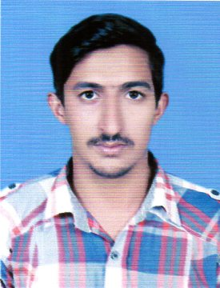

Muhammad Usman Rafique
Curriculum Vitae

HOUSE NO.10 BLOCK D-12 GOVERNER HOUSE LAHORE

Cell: 0332-4551871

E-mail – USMANRAFIQUE332@GMAIL.COM

Objective

To build a promising career in an organization where a lot of learning opportunities, growth prospect and challenging oriented environment exist.

Personal Profile

Father’s Name : Muhammad RAFIQUE

Date of Birth : 01-02-1994
Religion : Islam
Nationality : Pakistani
N.I.C.No. : 35202-3884868-9
Domicile : Lahore (Punjab)
Marital Status : Single

Qualification

- Metric : Lahore Board
- G.Sc. : Lahore Board
- B.Sc. : Punjab University

Experience

- Worked as Examination Officer at Superior University for 8 months

Computer

- Web & Graphic Designing
- Ms.Office , Inpage

Reference

- Will be provided on demand.

