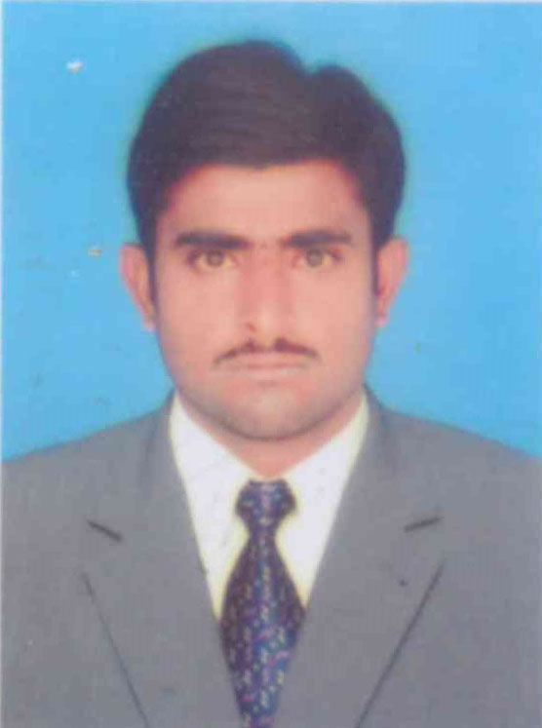
C
V
URRICULUM
ITAE

SAFDAR NAZEER

Address: Chak ramin P/O Kala Tehsil & District Dera Ghazi Khan.
Cell # 0342-7034135 0303-6343421
OBJECTIVE:

To work and grow with a prestigious organization that offers growth opportunity.
Where the efficient and hard working people with vision are mattered and where
Talent is considered.
PERSONAL DETAILS:
Father’s Name | Nazeer Ahmad
C.N.I.C # | 32102-8035924-3
Date of Birth | 02-January-1996
Marital Status | Single
Nationality | Pakistani
Religion | Islam
Email: | Safdarnazeer135@gmail.com
Languages | English, Urdu, Punjabi, Saraiki

EDUCATIONAL QUALIFICATION:
Degree | Years | Total Marks | %age | Board/University | Group
Matric | 2011 | 778/1050 | 74.09% | DG khan | Science
F.A | 2015 | 595/1100 | 54.09% | DG Khan | Arts
B.S (Edu) | 2019 | 2.89/4.00 | 63.62 | BZU Multan | Education

COMPUTER SKILLS:

- Internet Surfing
- MS Office
- Best grip on win xp,7,8,10

Experience:

