MUHAMMAD MAQBOOL
Bachelopr of Arts, Office / admin Management
Mobile No: 0307- 5852994
E- Mail ID: maqbool.qaiser68@gmail.com
Present & Postal Address: Arab Colony near Minhaj Post Graduate College, Qutba Morr, Kamra Cantt. District Attock

Permanent Address: Vill Kotly Jattan Post Office Noor kot
Tehsil Shakar Garh District Narowal

               
       

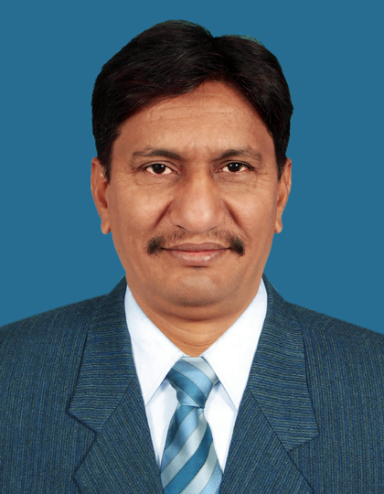

PROFESSIONAL SUMMARY

Retired from Pakistan Air Force as Chief Warrant Officer in Photographic Branch after completion of 25 years regular service. Have experience in Photo Technology, Office / admin management, Conversant with computer operations (MS office, Internet, windows), Monitoring and Evaluation, Report writing, Security Supervision.

Personal Details
- Father’s Name : Jamait Ali
- Date of Birth : 06 April,1968
- CNIC : 34502-1559495-9
- Domicile : Punjab
- Nationality : Pakistani
- Marital Status : Married
- Religion : Islam

ACADEMIC QUALIFICATION
Certificate / Degree | Discipline / Subject | Passing Year | Board / University | Div / Grade / %age of marks
Matric (Science) | Physics, Chemistry, Mathematics, Biology | 1983 | Board of Intermediate & Secondary Education, Lahore | 1st / A / 76.24%
Intermediate (F Sc) | Physics, Chemistry, Mathematics | 1986 | Board of Intermediate & Secondary Education, Gujranwala | 2nd / D / 48.27%
Bachelor (B. A) | Economics, Islamiyat | 1992 | University of the Punjab, Lahore | 2nd / C / 57.88%

Training / Certificate | Discipline / Subject | Passing Year | Institution | %age of marks.
DAE In Photo Technology | Airborne / Ground Photographic systems | 1989 | SOA, Pakistan Air Force K/Creek, Karachi | 62.12%
Military Leadership and Command Course | Management, Leadership | 2005 | JCO Academy, Pakistan Air Force, K/Creek, Karachi | 74.18%
JCO Supervisory Course | Administration | 2005 | SOA, Pakistan Air Force K/Creek, Karachi | 73.76%
Computer Familiarization Course | MS office, Internet | 2011 | BTS, Pakistan Air Force Minhas (Kamra) | 80.00%
PROFESSIONAL QUALIFICATION

WORK EXPERIENCE
Name of Organization | Post Held | From | To | Nature of Experience
World Health Organization  (EPI – Punjab), Pakistan | District Monitor (UNV) - Measles SIA  District Attock | Sep 2018 | Nov 2018 | - Provide administrative support to district health facilities.  - Monitor quality of preparatory activities; (Trainings / orientations, ACSM activities, AEFI management, waste management) conducted at district level.  - Conduct meetings with community leaders for support / cooperation.  - Conduct supervision of measles campaign using observers’ checklist as per guidelines.  - Collect field data from Health Facilities as per guidelines and submit online through android phones.  - Assist Health Management to prepare weekly, monthly and quarterly reports.  - Attend daily evening meetings with CEO (Health) / DC.
Population Welfare Department  (Punjab) | Monitoring and Evaluation Assistant  District Narowal | Jan 2016 | Dec 2017 | - Conduct regular field visits of Family Welfare facilities.  - Collect comprehensive field data as per the SOPs of the organization.  - Submit the collected field data through android phones (Tablet).  - Maintain record of all field activities at district level.  - Prepare a monthly progress report of activities performed during the month.  - Ensure adherence to departmental policies and procedures.  - Attend monthly project meeting with DMO.
Canteen Stores Department  (Lahore Zone) | Security Supervisor  (Security / vigilance Br.) | Jul 2013 | Jul 2014 | - Provide admin support to departmental stores.  - Conduct regular field visits to business venue.  - Collect comprehensive field data as per the SOPs of the department.  - Submit the collected field data online via Emails to Head Office.  - Prepare a monthly progress report of all field activities performed during the month.  - Ensure adherence to Business policies and procedures and undertake disciplinary actions.  - Carry out surprise stock takings (SST) of CSD shops.  - Feeding Updates to Head Office regarding robbery cases.
Pakistan Air Force / Pakistan Aeronautical Complex, Kamra | Administration / Supervision  (Office / admin work) | June 1989 | Mar 2012 | - Administration & supervision of photographic activities held at MRF PAC Kamra / PAF Formations.  - Maintain office files / documents in hard & electronic form as per SOPs.  - Carry out drafting and typing of official correspondences.  - Perform General Reception duties and work related errands.  - Organize and arrange professional trainings, meetings, events.  - Monitoring the examination process for quality trainings.  - Arrange accommodation and travel for trainee classes.  - Initiate office purchase orders, Obtain quotations, receive, store and distribute supplies and office materials.  - Maintenance of living accommodation and supervise janitorial staff.  - Maintain inventories of non-expendable items. Arrange any repair or replacements.  - Administration of equipment / material stores and maintain stock records cards / registers.  - Handle financial transactions of all property associate expenses and record office expenditures.  - Carry out audits of formations as directed by the Management authorities.  - Feeding updates to Head Office regarding Budget allocations and expenditures.  - Perform security supervisory duties.

ABILITIES / SKILLS
- Good time management and organization skills
- Good interpersonal and communication skills.
- Ability to work under pressure
- Self-starter attitude and good team player.
- Computer literate, with good MS Word, Excel skills.
- Having own conveyance (Motor Bike & valid driving licence).

Languages

- English. (Read, write, speak)
- Urdu. (Read, write, speak)
- Punjabi (Read, write, speak

EXTERNAL SKILLS

- Friendly, co-operative , honest, hardworking

