Najam Rafiq
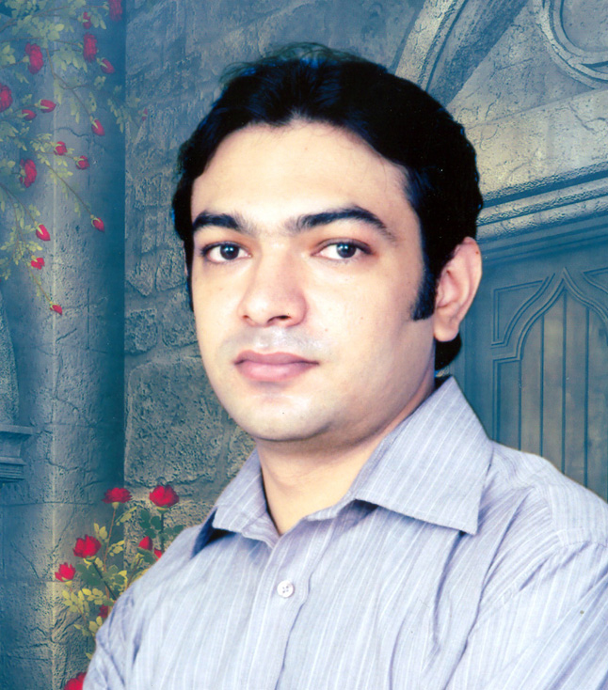

CAREER OBJECTIVE
To excel in professional environment and contribute significantly towards the growth of a dynamic organization that offers challenging opportunities for personal growth and skill development. I am organized, disciplined, fast learner and have ability to work independently.

WORK EXPERIENCE
August 2018 to Date  Non Linear Editor | Jurat TV  www.jurat.com.pk
May 2015 to May 2018  Front Desk Officer | The Bliss South Patong.  www.thebliss.com

Feb 2011 to March 2015  System Support Supervisor | LYCUST Management Solution.  www.lycust.com

September 2004 to Oct 2010  Imagesetter Operator | AM SCAN, Prepress Services  Rivaz Garden, Lahore.

ACADEMIC QUALIFICATION

October 2001 |  | University of Punjab
 |  | Bachelor of Arts

September 1995-1998 |  | Govt. Polytechnic Institute for Printing & Graphic
3 years Diploma of Associate Engineer
Printing & Graphic Arts

August 1994 |  | Z.M High School, Model Town, Lahore.
 |  | Matric (Science)

COMPUTER QUALIFICATIONS

May 2006 |  | Institute of Tourism & Multimedia Computing
 |  | Diploma of Multimedia (6 Months)

January 1999 |  | Apple Institute of Graphics, Davis Road, Lahore.
 |  | Diploma of Graphic Design (4 Months)

PERSONAL INFORMATION

Contact |  | 0310-4746169
Email |  | Najam.rafiq333@gmail.com
Marital Status |  | Single
Computer Skills Corel Draw13, Potoshop CS, Adobe Premiere Pro, Finalcut Pro, HTML

