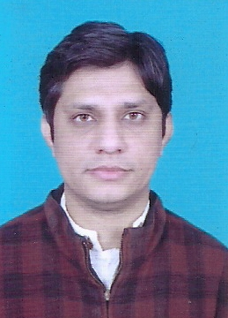

IMRAN ASLAM
Street No. 06, House No. 147, Allama Iqbal Road
Dharampura, Lahore
Cellular: 0323-8474323

OBJECTIVE:


To achieve the responsible position in the professional working environment and looking forward dynamically growing and progressive organization, where potential and skills can efficiently utilized in the best interest of the organization.

PERSONAL INFORMATION:


• Father Name : Muhammad Aslam
• Date of Birth : 01-12-1984
• CNIC No. : 35201-7364940-9
• Gender : Male
• Marital Status : Single
• Religion : Islam
• Domicile : Lahore (Punjab)

ACADEMIC RECORD:

Degree | Board/University/Institute
Matriculation | BISE Lahore
FSC | BISE Lahore
BSC | Punjab University Lahore
MA (Political Science) | Punjab University Lahore

COMPUTER SKILLS:

- MS Word
- Internet

EXPERIENCE:

- 06 years experience as Teacher to teach classes 8th, 9th, 10th.
  - Math, Science
9th, 10th
English Medium, Urdu Medium
Nabeel School Dharampura, Lahore
- General Math
9th, 10th
- Oxford Math
7th, 8th
- Physics
9th, 10, 1st Year
English Medium, Urdu Medium
- Chemistry
9th, 10th
- General Science Arts
9th, 10th
- Oxford Science
English
9th, 10th

LANGUAGE SKILLS:

- Urdu
- English
- Punjabi

REFERENCE:
- Luqman Aslam (Lecturer Chemistry) at FCCU 0313-4569381
- Muhammad Irfan Advocate High Court Lahore 0324-9472368

