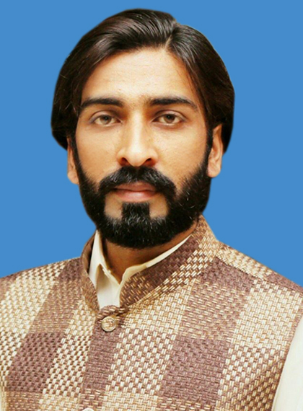

Asad Ali Javed

Curriculum Vitae
Date of Birth: | 19 | - | July |  | - | 1990 | Age: | 29 | Years
Address: | 400-B, Upper Portion, Sher Shah Colony, Raiwind Road Lahore
Contact: | (92-307) |  |  | 2114595 |  |  | Cell: | (92-335) |  | 7503380
Email(s): | asadghouri92@gmail.com
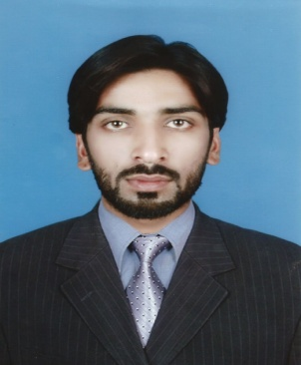
Objective: | To spruce my skills in an organization as a team member and give the best by learning and implementing all techniques at certain levels.

Professional Certification & Academic Education (most recent on the top)
Sr. | Certification / Degree | Institution / University | Specialization | Passing Year
1 | BS. Commerce (Hon’s) | COMSTAS, VEHARI | Finance | 2015
2 | I. Com | BISE MULTAN | Commerce | 2011
3 | Matriculation | BISE MULTAN | Science | 2009
Experience
- Worked as an Accounts and Admin Officer in Associated Business Technologies. (From Aug 18 to Nov 19)
- Worked as a PB Cross Sell in United Bank Ltd, Lahore. (From Feb 16 to Aug 18)
- Internship at United Bank Ltd Vehari. (From Jul 14 to Aug 14)
Computer Skills and Other Abilities
Sr. | Skills & Abilities | Proficiency Level | Last Used / Practiced
1. | Word Processing/Excel | Excellent | Currently Using
2. | ERP | Excellent | Currently Using
Social Membership & Co-curricular / Leisure Activities
Sr. | Description of Activities
1. | Youth Leadership Academy
2. | Reading Books
3. | Playing Cricket

Project/Research Papers
- Innovation in Rural Marketing in Pakistan.
- How We Develop E-information For the Secondary Level Students.
Personal Strength
- Communicational, Analytical and Administrative skills
- Excellent Co-operative Team Member
Language Competency:
- Urdu, English, Punjabi, Sraiki
- Good in English Language writing, speaking and presenting
Interest:
- Novelty through Research and Development by consulting Books, Internet, Conferences, and interaction with People… others.
- New Science News, including: (Technologies and Management).
- Islamic History
Personal Information:
Father’s Name: | Javed Akhtar Ghouri
Marital Status: | Married
CNIC No: | 36603-8855747-5
Religion: | Islam
Domicile: | Vehari

