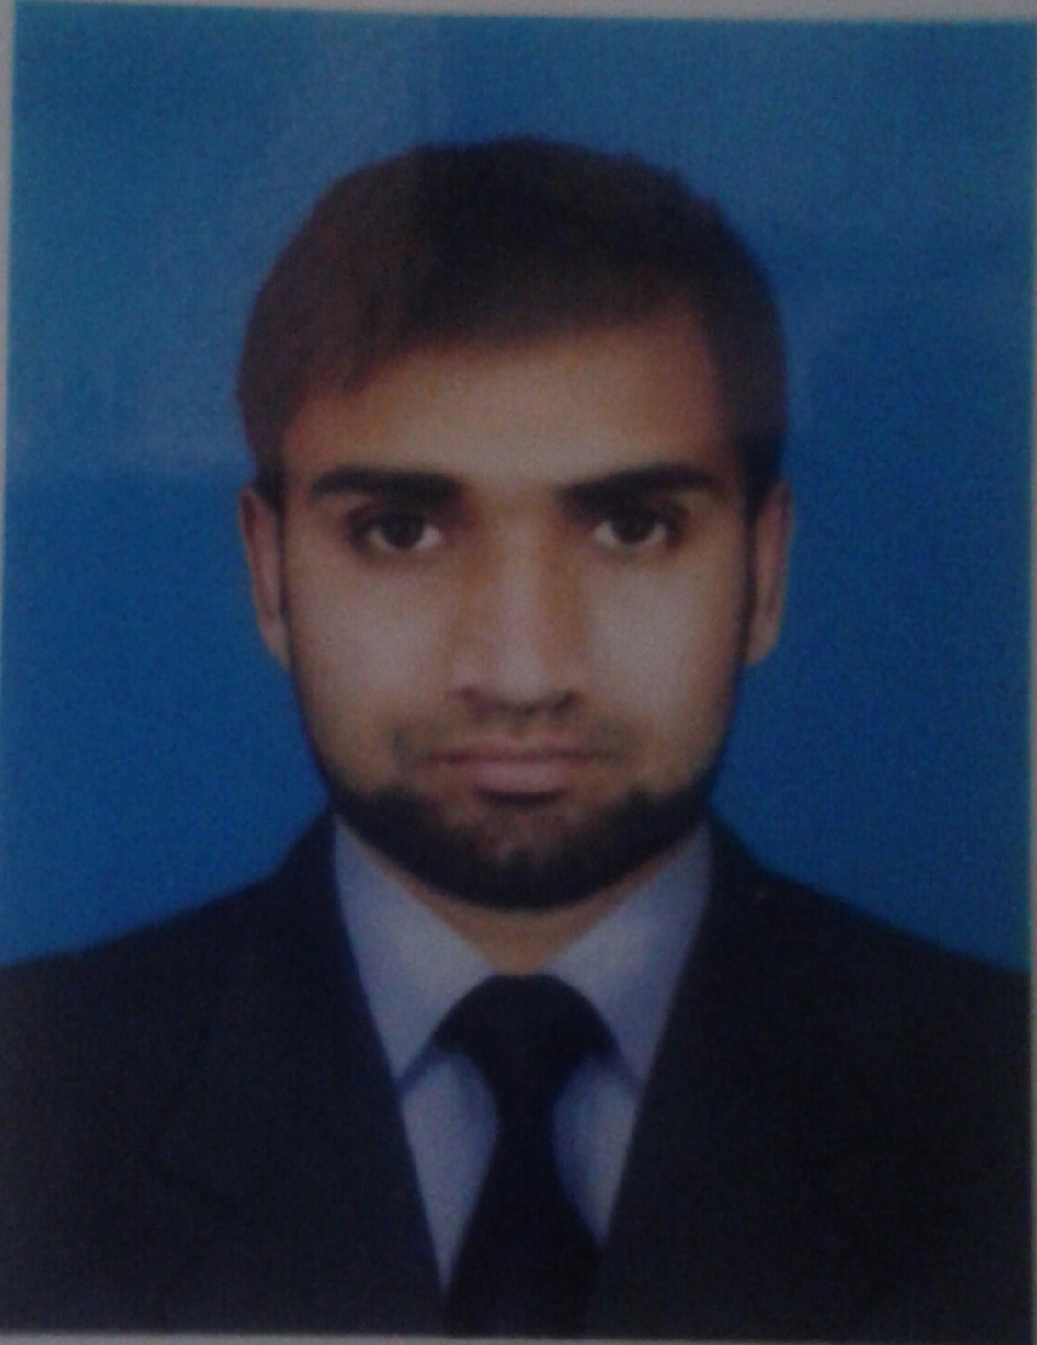
ZULFIQAR ALI
+92-340-1012279 • zulfiqarqazi786@gmail.com
• https://www.linkedin.com/in/zulfiqar-ali-333a07137/ • Age: 23
Education
UNIVERSITY OF AGRICULTURE, FAISALABAD (2.82 CGPA) Faisalabad, Pakistan
Bachelor’s in environmental engineering 2014-2018
- Leadership: Lead a team of 4 members in a project for checking groundwater quality of Faisalabad in 8th semester.
- Worked as an active member in society of Engineering and Technology by arranging different seminars and events.
Govt.pst post graduate college (808/1100) Kamalia, Pakistan
Intermediate (FSC Pre- Engineering) 2012-2014

Experience
ENVIRONMENTAL PROTECTION DEPARTMENT Lahore, Pakistan
Branch of international agency ‘Environmental Protection Agency’ which deals with project and their impacts on environmental health and safety
Internship: (May 2018 – July 2018)
- Teamwork: Learned how to prepare public hearing notice according to the regulations and PEPA Act 1997 for 45 days.
THE ART CLUB UAF Faisalabad, Pakistan
Largest event managing society at University of Agriculture, hosting diverse range of events year-round
General Member: 2016-2018
- Management Skills: Engaged with 8 other members as a logistic team for 20 days in a big event of UAF ‘Qissah 18’ that completed successfully.

Academic Activities
FINAL YEAR PROJECT (Groundwater sampling) Faisalabad, Pakistan
Checking of the effect of paharang drain on groundwater quality of Faisalabad.
Project duration: August 2017 – May 2018
Groundwater Quality Analysis- We found that groundwater in the area around paharang drain is contaminated with pollutants from industries and from the seepage of wastewater of paharang drain to ground. We gave recommendation that drain should be lined and industries should treat their wastewater before discharging it.

Trainings and Certifications
- Workshop on “Environmental Health and safety” held at UET Lahore (Faisalabad campus).
- Workshop on “How to get foreign scholarships” held at University of Agriculture, Faisalabad.
- Google Analytics certificate from Google academies
- 3 Months training course of “Safety officer” (NEBOSH) From Chichawatni college of Technology held under Punjab skills development fund.
- 3 Months training of E-Rozgaar under Non-Technical domain from Comsats University Islamabad, Sahiwal campus.

Honors and Awards
CHIEF MINISTER’S AWARD Faisalabad, Pakistan
- Received merit-based Laptop Award (2017)
- Awarded by the best drama performance at Environment Engineers get together.

Additional

- Skills: Microsoft Word, Excel, Snappa design Management, Leadership
- Certifications: Chinese Language Certificate HSK 1 (University of Agriculture, Faisalabad in 2017)
- Interests: Reading, Nature, Designing social media posts, Listening motivational speakers
- Languages: English, Urdu, Punjabi

