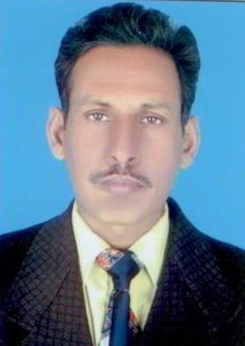
Curriculum Vitae

PERSONAL PROFILE

Name Muhammad Ali Asad
Father’s Name Abdul Sattar
Date of Birth 06-06-1974
Domicile Okara (Punjab)
Marital Status Married
Mobile # 0343-6749207
CNIN# 35303-2110566-1
Address Rehmatullah Colony St#1 Main Stop 54/2-L District Okara.
OBJECTIVE

Finding a challenging position in the field of business where I put my academic qualification, and field experience effectively for the growth of both prospective employer and myself.
QUALIFICATION
Degree | Division | Year | Institution/Board
Matric | 448/850 | 1991 | BISE Lahore
F.A | 440/1100 | 1994 | BISE Lahore
B.A | 372/800 | 2000 | Punjab University
M.A(Urdu) | 519/1000 | 2011 | Punjab University
PTC | 912/1200 | 1993 | Military Farm Okara

Experience

- I had been working as a Senior Teacher in Ahsan Public High School Renala Khurd ( Okara)
Since (April 2006 to 2008).
- I had been working as a Senior Teacher in Govt. Model High School Renala Khurd (Okara)
Since (September 2009 to 2010).
- I had been working Senior Teacher Urdu in Secondary Section kahnur Education High School Renala Khurd (Okara) Since (October 2010 to 2013)
- I had been working as a Subject Specialist of Urdu Gulberg Grammer School & College for Secondary and Inter classes since (April 2013 to May2016).
- I have been working Secondary Section as Urdu Teacher kahnur Education House Renala khurd (Aug 20 2016 to till date).
- Now I have been working urdu Teacher Secondary Section The Educators Rehman Campus, Renala Khurd Okara since March 01,2018 to till date.
REFERENCE

- Can be furnished on demand

