MUHAMMAD KHIZAR AMIN
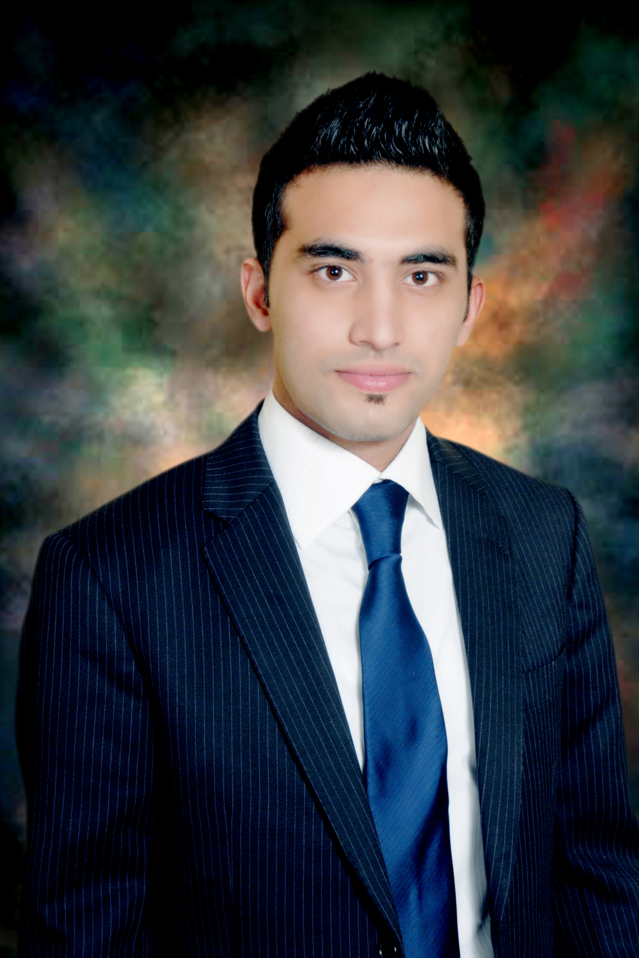

PERSONAL INFORMATION

Date of Birth: 12/02/1990
Home Address:
House # 24-Shah Jahan Street,
Islamia Park, Poonch
Road, Chuburji,
Lahore.
Telephone (Mobile): +92 (322) 8402120
+92 (333) 4351930 Email: khizaramin@gmail.com
C.N.I.C: 35202-6911100-3
Domicile: Lahore
Religion: ISLAM

PROFESSIONAL EXPERIENCE

Sep 2019 – To Date RIPHAH INTERNATIONAL UNIVERSITY, Lahore Campus
“Program Coordinator”
- Implementation of SAP S/4 HANA – 1809 ERP and Student Life Cycle Management Implementation"(SLCM).
- Serves as a central point of contact between students, faculty, and staff, other departments, and/or external constituencies on day-to-day programmatic, operational, and administrative matters; assists with seminars, meetings, special projects, and/or general problem resolution.
- Coordinates activities of support staff, consultants, faculty, and/or volunteers engaged in implementation and administration of program objectives.
- Keep updated records and create reports or proposals.
- Support growth and program development.
- Performs job-related duties as assigned.

Jan 2015 – March 2019. (Government of the Punjab)
Served as a Project Administrative Assistant (PSA)

Responsibilities:
- Uses a personal computer and a variety of office software applications including word processing, email, and file management. Creates documents in Word or uses predefined templates and form letters. Creates or maintains files in Excel. May create PowerPoint presentations and use Access or other databases.
- Coordinates, organizes, and takes minutes at meetings, and supports other department activities and functions.
- Also worked as a Monitoring & Vigilance officer in Model Town OPS Room. Controls the Crime rates of Model town Division through IT Based Software’s.
- Worked in IGP Office deals with online complaints though multiple software’s also report to the AIG Complaints.
- Handles requests/transactions or directs the person or matter to the proper sources. Assists in resolving problems and ensuring satisfactory customer service. Greet complainants of department by phone, in person or through electronic media. Assesses customer needs and explains services, processes, procedures and guidelines.
- Performs other related duties as assigned.

Nov 2012 – Sep 2013 Standard Chartered Bank(SCB) – Business Development Executive

Responsibilities:
- Responsible for activities regarding sales, marketing, customer acquisition, customer relation management, maximizing revenue and seasonally update sales documentation.
- Finding various new businesses opening & arranging promotional programs to get commercial business and attain set goals.
- Assessing market, current trends in market, finding competitors, also giving suggestions for product improvement
- Answering inquiry, questions & complaints of clients in order to keep revenue generation of the division.
- Post-appointment follow up to maintain relationships and develop referrals from existing client base. Client’s portfolio management, achievement of monthly targets and business development.
- I have also covered many different aspects of various duties providing support to the Partner and other senior managers such as time recording and organizing regular Team Meetings.

EDUCATION

2014 – 2017 University of Management & Technology (UMT)
(Masters) (Masters of Project Management)

2012-2012 SKANS School Of Accountancy, Lahore.
ACCA (UK) Level-1 & Level-2(4 Papers)

2009 - 2011 SKANS School Of Accountancy, Lahore.
CAT (UK)
CAT {UK} (Certified Accounting Technician) /
FIA (Foundation in Accountancy)

2008 - 2010 University of Punjab, Lahore
(B.COM) Govt. Islamia College of Commerce,
(Accounting & Finance) –2nd Div.

2005 - 2007 (Govt. Islmiya College, Civil Lines Lahore)

F.A (General Sciences): Mathematics
Statistic
Economics
2003 - 2005 Govt. Central Model High School, Lower Mall, Lahore.

Matric (Science): Maths [A], English [A], Chemistry [A], Physics [A], Biology [A]

Skills:

- Typing skills – 30-35wpm both in English & Urdu.
- Computer and technical skills (including software knowledge)
- Organizational and time management abilities
- Administrative skills
- Communication (written and verbal)
- Customer Service
- Multi-tasking
- Confidentiality
- Ability to work independently and as part of a team
- Phone skills and etiquette
- A positive attitude towards customer Satisfaction.

Teaching Experience:

2012 - Present Academy Teacher & Independent Tutor

- Presenting lessons in a comprehensive manner and use visual/audio means to facilitate learning
- Created Lessons plans responsive to Individual student’s needs in relation to classes
- Directed learning to achieve student engagement with material.
- Providing individualized instruction to each student by promoting interactive learning
- Creating and distributing educational content

CERTIFICATIONS

          - Consulate General of Pakistan Hong Kong
TEXPO-11th -14th April 2019 @ Expo Center Lahore -Pakistan
Assigned as GRO (Guest Relationship Officer) by
Trade Development Authority of Pakistan (TDAP)

- Government of the Punjab
Punjab Information Technology Board (PITB)
E-Rozgaar Certification
Content Marketing & Advertising, Freelancing, WordPress,
SEO (Search Engine Optimization) Digital Marketing, Blogging
      - ENGLISH LANAGUAGE (British Council)
IELTS (International English Language Testing System)
BETS (British Education & Training System) (Score 6.0)

          - COMPUTING KNOWLEDGE:
(Operating Systems Packages)
Highly competent in the use of Microsoft Office applications (including Microsoft Word, Excel, PowerPoint) MS Project, Photo Paint.

REFERENCE

Reference will be provided on request.

