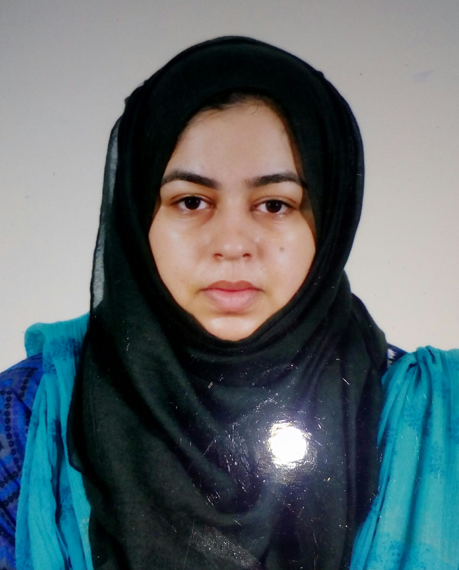
AMNA KHALID
House: 22-D, Block: R, Street: 3, Marghzar Officers Colony, Multan Road, Lahore.
Cell: 0334-8336976
Email: akhalid252@gmail.com
JAWAD AHMAD

House #11, Street 6, Babu Sabu, Bund Road, Lahore, Pakistan
Mobile: +971 50 735 4665

PERSONAL PROFILE

Born on November 01st, 1994, Married, a Pakistani National, Urdu & English speaking, hard-working, takes initiative, and can work with less supervision.

CAREER OBJECTIVE

I am hardworking, enthusiastic, confident, and dedicated person who like to work both individually as well as in teams. I have the will, the zeal and the motivation to propel in the increasing dynamic working environment in the realm of Accounting & Finance.

ACADEMIC PROFILE

BS Hons. – English Studies | 2012-2016 |
Govt. Post Graduate College (Sub Campus of Gujrat University), 6th Road, Satellite Town, Rawalpindi.

Intermediate in Humanities | 2010-2012 |
Govt. Post Graduate College (Sub Campus of Gujrat University), 6th Road, Satellite Town, Rawalpindi.

Matriculation | 2008-2010 |
New Siddeeq Public Secondary School, 76-A, Satellite Town, Rawalpindi.
WORK EXPERIENCE

English Teacher – BPS 16 |November 2016 – January 2020|

Army Public School & Colleges System (APSACS), Sher Khan Complex, G-11 / 4, Islamabad.

Duties and Responsibilities:
- Worked as class teacher.
- Worked as spoken English coordinator.
- Planned summer break task and hosted competitions at junior level.
- Planned worksheets for students.
- Script writing for mega dramatics competition at junior level.
- Conducted seminar and workshops on topics related to raising emotionally healthy children
TRAININGS & WORKSHOPS

- SMILES Programme
- Cambridge Book Base training
- B-TEC Beginners
- B-TEC Advance
- British Core Skills
SKILLS

- Microsoft Office
- Windows, Android & iOS operating systems
- Computer Software and Internet Applications
BEYOND ACADEMICS

- Reading English literature and watching series or movies related to such stuff.
- Worked as chief editor in university magazine.
- Researching material related to any specified topic.
REFERENCE

- Principal Mrs. Huma Tabish (APSACS G11/4 Branch)

