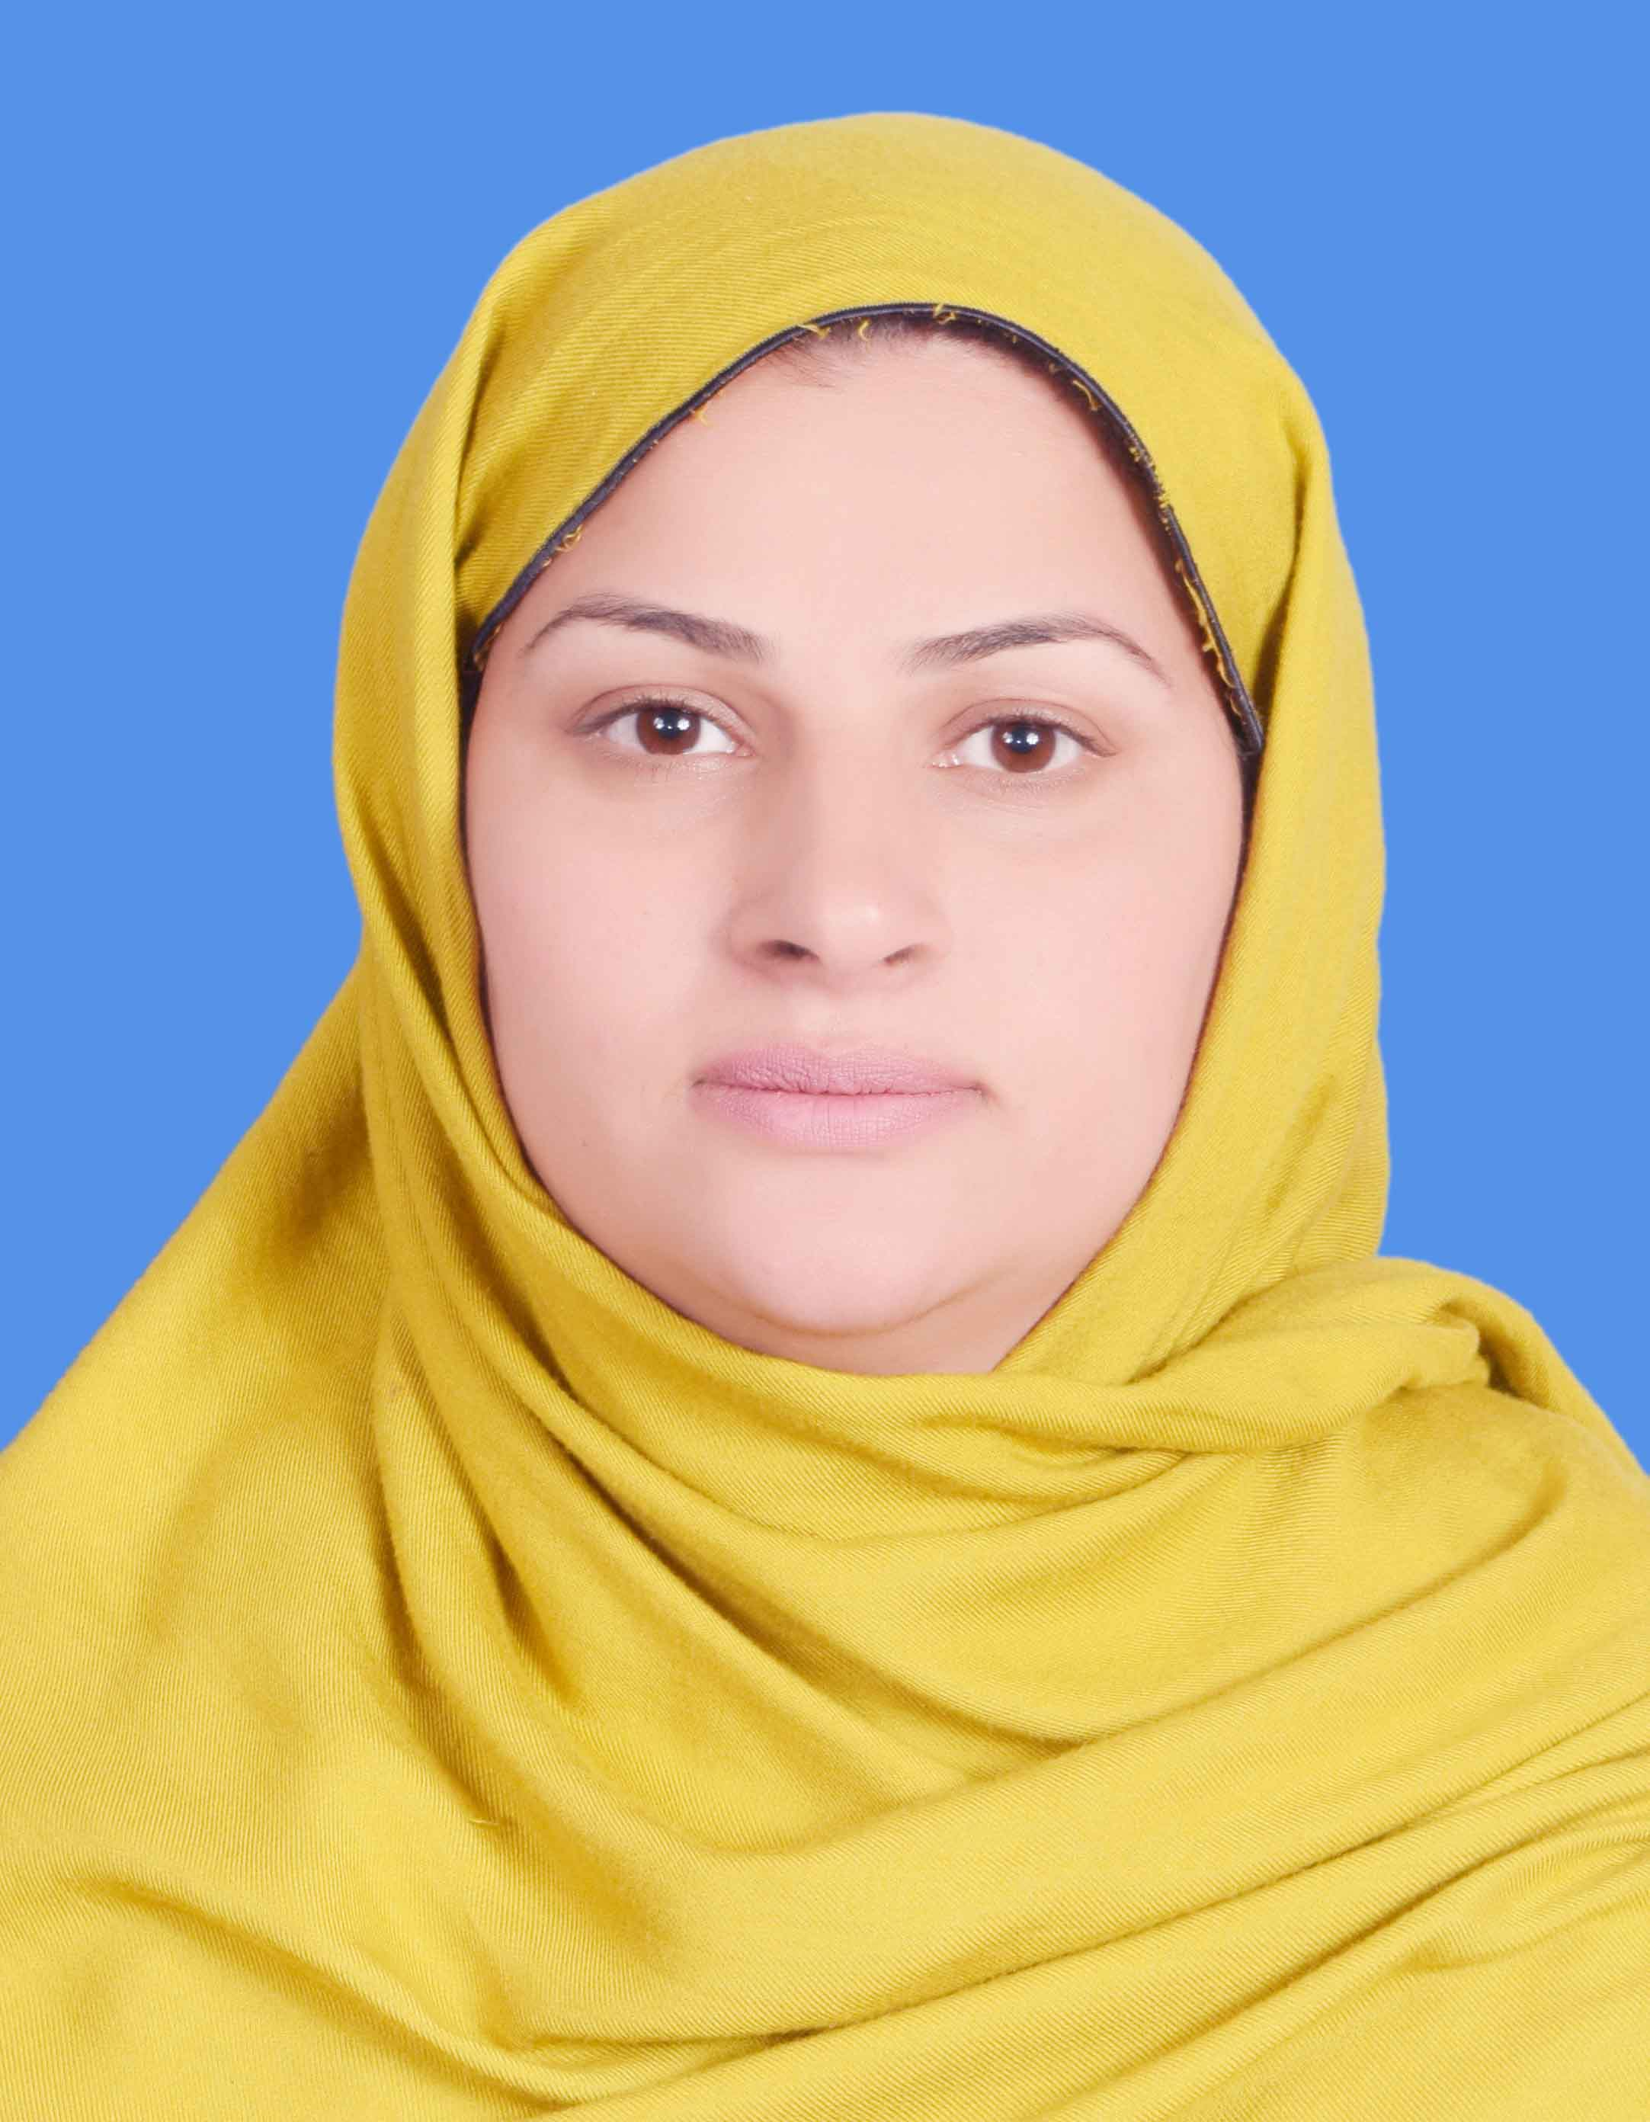
RESUME

BEENISH BASHIR

Academic Qualification:

Year | Degree | University/Board
2019 | Diploma TEFL | AIOU Islamabad
2018 | MA Education | AJ&K University Muzaffarabad
2014 | MA English | AJ&K University Muzaffarabad
2011 | B.Ed. | AJ&K University Muzaffarabad
2010 | B. A | AJ&K University Muzaffarabad
2008 | F. A | Mirpur Board Azad Jammu & Kashmir
2001 | Matric | Mirpur Board Azad Jammu & Kashmir

EXPERIENCE:

- 2 years teaching Experience of The Knowledge City School as a English Teacher.
- 2 years teaching Experience of AIMS School & College as a English Teacher.
- Working as Principal The Citizen Foundation School (Primary Section) Muzaffarabad (Kingran) Branch from September 2016.

EXPERIENCE WITH TCF:

Helding Community visit for student strength and promoting the vision and mission of TCF.
Giving demo lesson to teachers. Also working as, a subject specialist of English. Planner checking and giving constructive feedback. Attending principal meetings at area level. Attending SDD, S every month. Preparing teachers for TCT.

COMPUTER SKILLS & OTHER COURSES:

- 6 months Computer Course from Pakistan Red Crescent Society (PRCS).
- 3 months Spoken English Course from AJ&K University Muzaffarabad.

WORKSHOPS & TRAINING:

- 4 days Active Citizens Workshop from British Council Muzaffarabad.
- 1-day Workshop on Community Mobilization Training from PRSC.
- 1-day Workshop on Psychological First Aid Training from PRSC.
- 1-day workshop on Worker Support Training from PRSC.
- 1-week Principal Academy training from TCF.
RESPONSIBILITIES AS A TEACHER:

Preparing lesson, making them all interesting as possible. Mark Homework and pieces of assessment. Preparing assignment sheet and activity sheets. Checking syllabus and designing project by the students. Maintain records (A-register, planner AC-file etc.). Handel out student issues. Identify the needs of individual students in their classes and work to help each child develop his or her own potential. Generating reports on monthly basis to principal. Produce written project outlines and session plans. Keep up to date with all current course information and promote and disseminate this information when necessary. Assist with the Academy teacher performance management through teacher observation and feedback sessions.

COMMUNICATION SKILLS:

Having fluency in writing and speaking in English.
PERSONAL PROFILE:

Husband name: Adeel Ashfaq Awan
CNIC # 82203-8028580-0
Marital Status: Married
Religion: Islam
Cell # +923345721813, 0334-5721989
E-mail: adeelptv@yahoo.com
Address: Near The Knowledge City School Upper Chatter Muzaffarabad
HOBBIES & INTEREST:

Reading books, Search on internet etc.

