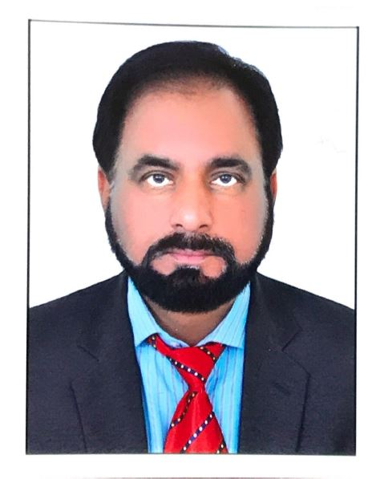

**Muhammad Asghar**

+923034337139, asghar563@yahoo.co.uk

03121430026- 03127691453

**Objective**

To join a career oriented and learning based organization where I can apply my knowledge and update it with the coming innovations in the field.

**Experience Summary**

* Lecturer in Biology Pakistan International School. KSA (1997 to till 2019.) teaching the Biology to SSC and HSSC Classes O, Level and, A, Level. at IGCSE Cambridge and Edexel levels
* Scientific Officer Pakistan Science Foundation, Islamabad Pakistan Study different flora of Pakistan (from 1990 to 1992)
* Scientific Officer Rangeland Research Institute in NARC, Islamabad (from 1995 to 1997)

**Skills Summary:**

Served as Teacher Coordinator for three years in PIS Buraidah KSA

* Studied the flora of Naran Kaghan with the University of Japan Professionals and compiled in the form of book.
* Worked in Sloping Agriculture Land Technology (SALT) to conserve the environment of mountain areas Under the auspices of ICIMOD.
* Sound knowledge for treating the waste water with the help of plant and microorganisms.
* Silviculture experience to grow the trees in waste places.
* Agro forestry knowledge to grow plant in agricultural fields.

**Education & Certifications:**

* M.Phil – Biology – 2014 - University of Agriculture Peshawar, Pakistan.
* M.Sc – Botany – 1988 – University of agriculture Faisalabad, Pakistan.
* B.Sc – Science – 1985 – University of Punjab, Lahore, Pakistan.
* Training Certificate – Agroforestry & Silviculture from UK.
* Training Certificate – Bio Technology & Bio Genomics from NARC Islamabad, Pakistan.
* Certificate of Quran Reading, Translation & Explanation with Ref. to Hadith from Foreign Islamic Education Department of Saudi Arabia.
* Certificate for learning of 5 pillars of Islam and Prophets Life with ref. of Quran & Had`ith.