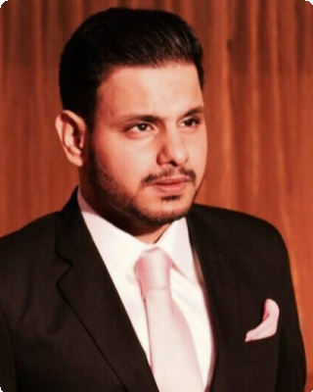Arsalan Khalid

E-mail : Phone : 00923349445100 mian-arsalan@hotmail.com Address:

205-D State Life Housing Society Phase 1 Lahore

**Experience**



AnK Enterprise May 2019

Partner

Lakhesar Traders Jan 2014 — Sep 2017

Sales and Marketing manager

**Professional Certification**



(CFIA)Certified Forensic and Investigative Auditor,Canada (july 2014)

**Education**



|  |  |
| --- | --- |
| Ordinary Level | 2003 — 2006 |
| *Aitchison College Lahore* |  |
| Advance Level | 2006 — 2008 |
| *Resource Academia Lahore* |  |
| Advance Diploma in Business and | — 2012 |
| Accounting |  |
| *ACCA* |  |
| Bsc(hons) Applied Accounting:   * Corporate and Business Law * Performance Management * Taxation * Financial Performance * Financial Managment * Audit and Assurance | 2013 |
| *Oxford Brookes University,UK* |  |
| Masters in Business Administration  First semester GPA (3.7)   * Strategic Management * Global Marketing * Corporate Finance * Quantitative Techniques in Business * Human Resource Development * Corporate Governance * Business Research Methodology * Project Management | 2018 — 2019 |
| *Superior University,Lahore* |  |

**Teaching Experience:**

* Privately taught Mphil students the following subjects: 2018

1. Global Marketing
2. Corporate Finance
3. Strategic Management
4. Corporate Governance
5. Project Management

* Private business studies, economics, Pakistan studies and commerce home tuitions to Ordinary Level students 2017-2018

**Area of teaching**

* Ordinary Level Business Studies
* Ordinary Level Accounting (grade IX)
* Ordinary Level Economics
* Ordinary Level Commerce
* Ordinary Level Pakistan Studies
* Ordinary Level English

**Interests:**

* Teaching
* Research
* Debates
* Gymnasium

References

References available upon request.

Arsalan Khalid 2