|  |
| --- |
| **MESSUM ALI**  **Postal Address**: 12 C1 Al Hussain Manzil Shah Kamal road behind Wahdat colony Lahore.  **Present Address**: 12 C1 Al Hussain Manzil Shah Kamal road behind Wahdat colony Lahore.  **Contact #**: 03234561412  **E-Mail: meesumali1@gmail.com** |

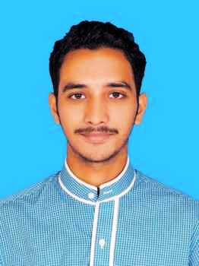

|  |
| --- |
| **OBJECTIVE** |

Seeking a challenging, development-oriented career within a dynamic and progressive organization where enthusiasm, dedication and the ability to manage tasks effectively are the pre-requisite in driving the organization forward.

|  |
| --- |
| **ACADEMICS** |

**Masters in English 2017**

2.8 CGPA

Major: English Literature

Special Subject: Literature around the world (In Final semester)

University of the Punjab, Lahore

**Bachelors in Arts 2014**

2nd Division

Major: English Literature

Punjab University

**Intermediate 2012**

1st Division

Major: (Pre Engineering)

Punjab College, Lahore

**Matriculation (Science Subjects) 2010**

1st Division

Major: Science Subjects

Govt. Central Model School lower Mall Lahore.

|  |
| --- |
| **SKILLS& COCURRICULAR ACTIVITIES** |

* Poetry (reading and writing).
* Good Communication Skills, Team Work, Time Management.
* Organized yet creative thinker who can develop goals, write lesson plans, gather supplies and implement plans in a fun and positive environment.
* Debating, Comparing, Event Management.
* Ability to adapt in new team & Environment.
* Participated in the sports gala held at the Department of English language and Literature, University of the Punjab Lahore.
* Participated in a play titled “Laal” as a leading role held at the Department of English Language and Literature, University of the Punjab.
* Three months Course of Spoken English from ‘BETS’.

|  |
| --- |
| **FIELD OF INTEREST** |

* Teaching
* Report writing
* Content writing
* Career counseling

|  |
| --- |
| **PERSONAL INFORMATION** |

* Father Name: Muhammad Mustafa Zahid
* Domicile: Lahore
* Date of Birth: 24-08-1993
* Marital Status: Single
* Languages: English, Urdu, Punjabi

|  |
| --- |
| **PROFESSIONAL EXPERIENCE** |

* Two year teaching experience at Allied School.

|  |
| --- |
| **REFERENCES** |

Will be furnished upon demand.