### ZAHID HUSSAIN GILANI

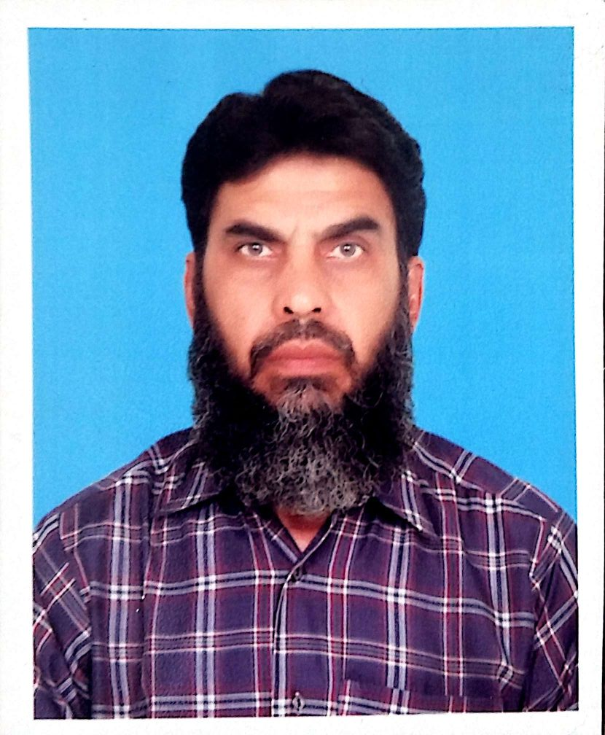

|  |  |
| --- | --- |
| **MAILING ADDRESS**  H# 83, Phase III, AGRICS Town, Lahore – 54770, Pakistan. | **PHONE** +92 333 4234292  **Mobile** +92 333 4234292  **EMAIL**  zahidgilani4@gmail.com |

**SUMMARY**

* Science graduate in Applied Mathematics having more than 25 years’ versatile and dynamic work experience in both teaching and administration
* A result oriented, achiever and a passionate academician
* Teaching experience in highly reputed institutions like; Atchison College Lahore, Beaconhouse school systems, LACAS school systems, Garrison Boys School, and Army Public School as well as part time teaching in renowned academies
* Teaching Mathematics at O levels, Matric and Intermediate level
* Having good command on computer software; Microsoft office
* Having experience of paper marking with Lahore Board for 9 years

**ACADEMIC QUALIFICATION**

|  |  |
| --- | --- |
| **1.** | **Masters in Applied Mathematics 1st Division**  University of the Punjab |
| **2.** | **BSc. Mathematics A & B course with Physics 2nd Division**  University of the Punjab |
| **3** | **F.Sc. Pre Engineering 2nd Division**  Govt. Islamia college Lahore (Lahore Board) |
| **4** | **Matriculation (Science) 1st Division**  Govt. Comprehensive School for Boys Lahore (Lahore Board) |
| **5** | **B.Ed. with. Mathematics and Physics 2nd Division**  **Govt. Education College for Men. Lahore** |

**PERSONAL PROFILE**

|  |  |
| --- | --- |
| Father’s Name | Syed Zafar Hussain Shah |
| Date of Birth | 02 -04 -1964 |
| N. Id. C #  Nationality | 35202-2315871-5  Pakistan |
| Marital Status | Married |

**Professional courses and Workshops**

1. Certificate in computer programing
2. Class room management
3. Exam and syllabus development organized by British Council

**WORKING PROFILE**

1. **Crescent College for Boys Shadman Lahore as Maths Teacher ( Visiting Faculty ) since August 2018.**
2. **Beaconhouse School System (JTC) as Maths and Add Maths Teacher ( Visiting Faculty) Since August 2017.**
3. **Worked as Maths Teacher for Entry Test 2019, at Step institute Bahria town Lahore.**
4. **Worked as part time Maths Teacher at UCP for ADP classes from August 2016 to May 2017.**
5. Punjab college Shahdra Campus Lahore, as a Mathematics Teacher, from January 2016 to August 2017.
6. Aitchison College Lahore, as an O-Level Mathematics Teacher from September 2013 to December 2015.
7. Beaconhouse Newlands 239 DHA phase VI, as an O-Level Mathematics Teacher from August 2011 to August 2013
8. The Lahore Alma 48-C DHA Lahore, as an O-Level Mathematics and Additional Mathematics Teacher from October 2001 to August 2011.
9. LACAS Burki Campus Lahore, as an O-Level Mathematics Teacher from August 2010 to June 2011.
10. Beaconhouse School System J. T. Girls Campus Lahore, as an O-Level Mathematics and Additional Mathematics Teacher from October 1998 to October 2001.
11. Garrison Boys High School Lahore Cantt. as a Mathematics Teacher from August 1995 to September 1998.
12. Army Public School Gujranwala Cantt. as a Mathematics Teacher from August 1992 to September 1995.

**PART TIME WORKING PROFILE**

1. KIPS Chauburgy Campus Lahore. As a mathematics teacher for F. Sc. since May 2014.
2. Crown Educational Centre DHA Lahore. As a mathematics teacher for, Fsc, O-level and A- level from June 2007 to May 2014
3. Shahid Sethi Academy Shadman Lahore, As a mathematics teacher for matric and F.Sc. from 1995 to 2007.

**REFERENCES**

1. **Prof. Dr. Aamir Ijaz**

Director

Chemical Engineering and Undergraduate Studies

University of the Punjab,

Lahore, Pakistan.

Email: **[ijazaamir@yahoo.com](mailto:ijazaamir@yahoo.com)**

1. **Dr. Muhammad Qaiser Shahabaz**

Professor and Chairman

Department of Statistics,

COMSTAS Institute of Information Technology,

Lahore, Pakistan**.**

**Email: [drmqshahbaz@ciitlahore.edu.pk](mailto:drmqshahbaz@ciitlahore.edu.pk)**