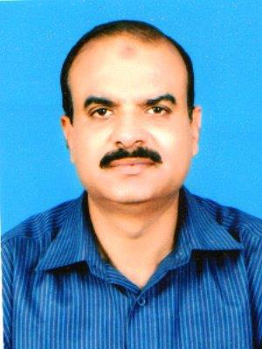

**Mob #:03324572297**

**Skype id:** arshad.farooq40

**Email:**59arshad@gmail.com

**ARSHAD FAROOQ**

Profession:

Year of Birth:

Teaching: Economics (O & A Levels), Mathematics (O Level)

1959

**Objectives:**

* Work as Economics / Mathematics teacher.
* Guide the students in achieving the learning outcomes and excellent grades.
* Work for the growth and expansion of the institution.

**Teaching Skills**

* Good communication with colleagues, students and the parents.
* Effective interpersonal skills.
* Ability to prepare and motivate students for Cambridge exams.

**Language Skills**

* Proficient in English and Urdu.

**Education:**

* **Certificate in Professional studies in education,** Bradford University U.K.
* **Post Graduation (Economics),** Government Forman Christian College, Lahore.
* **Graduation (Stats, Mathematics, Economics)** Govt. College of Science, Lahore.

**Professional Experience:**

**September 2014 till September 2019**

* Worked as subject teacher (Economics)
* English Language School, Dubai. UAE

**August 2011 till June 2014**

* Taught Economics as Visiting Faculty member at Mus’ab School System Lahore, Pakistan.

**September 2008 to August 2011**

* Taught Economics as Visiting Faculty member at ESENA Foundation School, Pak Turk International School and Musab School System.

**September 2003 to September 2008**

* In charge; students’ guidance and counseling cell Beaconhouse School System Liberty Branch Lahore, Pakistan.
* Senior Teacher (Economics& Mathematics) Beaconhouse School System, Johar Town campus Lahore, Pakistan.
* External Examiner (M.A Economics) University of the Punjab, Lahore, Pakistan.

**September 1994 to September 2000**

* Patron; Students’ Welfare Society.
* Administration officer, Controller of examinations, Senior Teacher, Mansoora Model Degree College Lahore.

**April 1989 to September 1990**

* Research Officer, Punjab Health Department, Civil Secretariat Government of Punjab, Lahore.

**Achievements**

* Produced excellent results in Cambridge O & A Levels Examinations throughout the teaching career. Produced 100% As in Economics at Johar Town Campus in 2008.
* Awarded appreciation letter by the Director Academics Beaconhouse School System.
* Awarded appreciation letter by the Principal Johar Town Campus on excellent performance as teacher.
* Member School evaluation team, Beaconhouse School System.
* Awarded special Honorarium for extra arduous duties by Secretary Health, Government of the Punjab.

**References**

References would be furnished if required.