**Zeeshan Irshad** 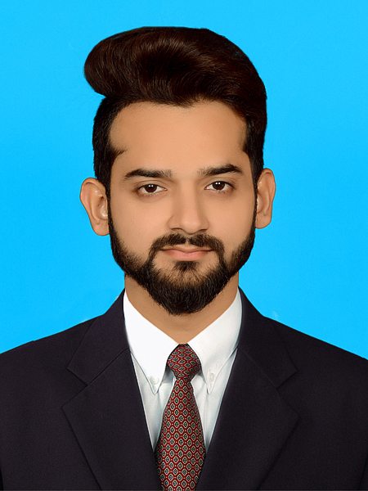

**Permanent Address:** H#2035, St No. 15 Farooqabad, Mansoorabad, Faisalabad.

**Objective:**

To get knowledge, experience and competitive environment to obtain a higher position in a well-reputed organization that actively promote personal and professional growth.

**Personal Details:**

|  |  |
| --- | --- |
| Father’s Name | Irshad Ahmad |
| Date of Birth | 10-09-1991 |
| Marital Status | Single |
| Nationality | Pakistani |
| Religion | Islam |
| Domicile | Punjab |
| CNIC No | 33102-3430666-9 |
| Cell No | 0321-6600684 |

**Educational Qualification:**

|  |  |  |  |  |
| --- | --- | --- | --- | --- |
| **Title** | **Year** | **Group** | **Percentage** | **Institute** |
| M.Phill | 2016 | Commerce | 74. 64% | GC University Fsd |
| Master | 2013 | Commerce | 60.14% | GC University Fsd |
| Graduation | 2011 | Commerce | 60.40% | Punjab University |
| Intermediate | 2009 | Commerce | 58.45% | BISC Fsd |
| Matriculation | 2007 | Science | 61.65% | BISE Fsd |

**Languages:**

English, Urdu & Punjabi.

Have Good Communication Skills.

**Professional Experience:**

2 Years at Weave Style as part time Accountant from year 2012 to 2014.

3 Year at FM Textiles (Pvt) Ltd. as full time Accountant from year 2014 to 2017.

2 Years at Interwood Mobel (Pvt) Ltd. As Accountant From year 2017 to still continue.

1 Year Teaching in home tuitions.

Teaching in Private Academy is continue.

**Professional Skils:**

6 Months Diploma in Computer Application in Business.

3 Months Diploma in Textile Dyeing & Printing.