M Farrukh Hafeez 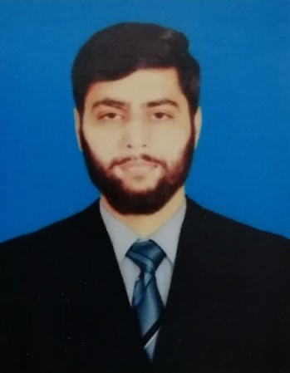

Contact : 0335-3574786

**Address:**

**House no 271 Block G5 Phase 1 Wapda Town Lahore.**

**OBJECTIVE**

***To*** *work with an aggressive and motivated team of professionals seeking goals of*

*Future and to apply professional and academic knowledge to challenging tasks*

*Leading to growth and development of organization and career developer.*

**PERSONAL INFORMATION**

Father’s Name : Hafeez – Ur – Rehman

Date of Birth : 15 Oct 1996

Religion : Islam

Marital Status : Single

Contact # : 0335-3574786

E-mail : farrukhhafeez48@gmail.com

**ACADEMIC QUALIFICATIONS**

|  |  |  |  |
| --- | --- | --- | --- |
| **Qualification** | **Passing Year** | **%age** | **Institution / Board** |
| Mphil | 2019 Continue | Continue | University of Lahore |
| Bs in  Computer science | 2014 to 2018 | 61%  (2.6 CGPA) | Superior University Lahore |
| Fsc | 2014 | 73% | Superior College  Bahawalpur |
| Matriculation | 2012 | 62.4% | Govt City High SchoolBahawalpur |

**TRAININGS**

|  |  |  |  |
| --- | --- | --- | --- |
| **Qualification** | **Passing Year** | **%age** | **Institution / Board** |
| Certificate in Computer Application (CCA) | 2014 | 94% | Punjab Vocational Training Council Lahore |
| Auto mobile | 2012 | 77% | Punjab Vocational Training Council Lahore |

**EXPERIENCE**

|  |  |  |
| --- | --- | --- |
| **ORAGNIZATION** | **DESIGNATION** | **DURATION** |
| *Zafar & General Store* | Cashier | 1 year |
| *The Lahore Academy* | Teacher (Computer & English )  Middle to Intermediate | 2 year |
| *The Student Academy* | Teacher( Computer & English  & Pakistan studies )  Matriculation to Intermediate & O/A level | 1 year |
| *The Root Academy* | Teacher (Computer & Islamiat )  Class 2 to Matriculation | 2 month |

**CERTIFICATE**

|  |  |
| --- | --- |
| **Certificate name** | **Institution** |
| Human development program | Pakistan psychological Association(PPA) |

**COMPUTER SKILLS**

* Error and Handling
* MS (Office, Excel, Power Point)
* Hardware and Software
* Programming & coding
* Networking & Security
* Front hand development
* Word press
* Mobile Application development
* Database management & development
* Software analysis and design
* Proposal or Documentation writing
* Diagrams designing
* Content writing
* Social media marketing

**REFERENCES**

*Reference will be furnished if required*