* 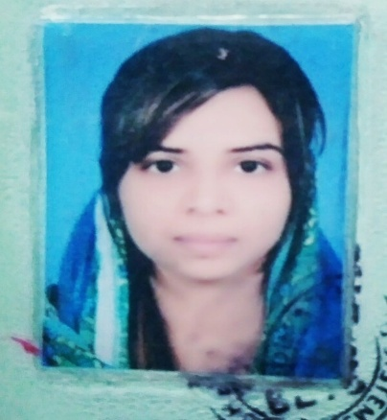**Zurva Rehman**
* Jazilrehman@gmail.com

+923364364904

191, 3A2 township, lahore.

**Objectives:**

I am seeking for competitive and challenging environment to serve with my experience and knowledge. Where I can get the opportunities to grow.

**Qualification:**

|  |  |  |  |
| --- | --- | --- | --- |
| Institution | Academic year | Degree | Marks/cgpa |
| University of south Asia, Lahore. | 2010-2012 | MBA(finance,marketing) | 3.67/4 |
| Oxford degree college,sheikhupura. | 2009 | B. Com | 843/1500 |
| Open university lahore | 2016 | B. Ed | 601/900 |
| Govt. Girls college depalpur. | 2005 | Fsc(pre medical) | 518/1100 |
| Govt.girls high school,depalpur. | 2003 | Matric with science | 601/850 |

**Professional courses:**

To get the experience and to enhance the knowledge I did the **Institution management course** form GMCI in 2019.

In which I learnt about office work ,work on MS office as well as how to teach students without talking.

**Experience:**

* Worked as an internee in The Bank of Punjab in 2012.

**Projects:**

* Prepare a report on work life balance of Uk,Usa and eastern Euroap.
* Project on rice export.
* Project for small and medium entrepreneur.
* Overview of people in organization.
* Project on food plan of teenage children of pakistan and introduce new product in their plan.

**Skills:**

* Team oriented.
* Excellent communication skills.
* Knowledge of MS office.
* Hard work to get end goals.
* Adventurous and prefers to work in challenging environment.