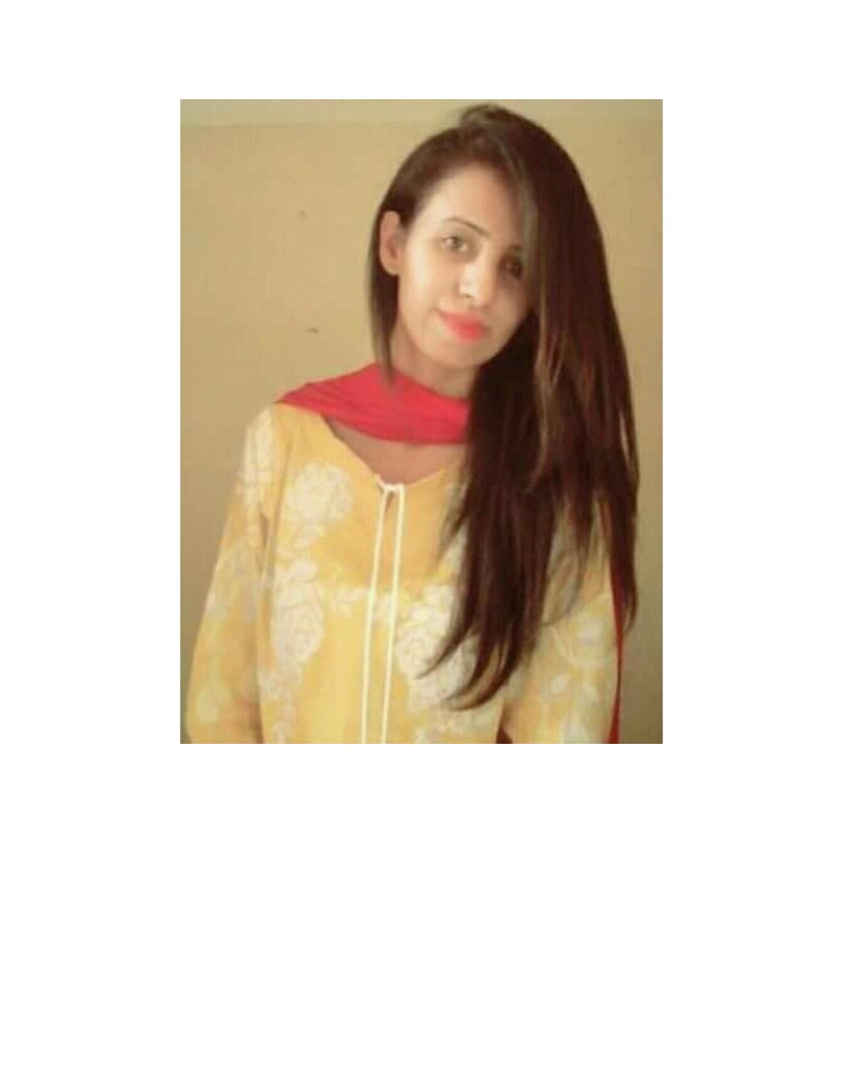

**Mishi Javed**

**Name:** Mishi Javed

**D/o**: Javed Hussain

**D.O.B:** 24-07-1996

**Gender:** Female

**Religion:** Islam

**Nationality:** Pakistani

**Marital Status:**  Single

**CINC NO**: 37401-2219981-8

**Address:** Rajput house No 6 ,St no 2 Angoori Park Shalimar link Road Baghbanpura Lahore.

**E-mail:** mishijaved63@gmail.com

**Contact no:** 03310409977

**Objective:**

To be a part of such a competitive discipline, where learning is the source of motivation, creativity is the fashion, dignity is the principle, and performance/merit is the criteria, where one can visualize his contribution towards the achievements of organizational goals and leader of his development.I wish that I will be successful by the grace of Almighty Allah.

**Career Objective :**

To get a career oriented job in a well reputed organization that offers full utilization of my skills and provide learning opportunities.

**Academic Career:**

|  |  |  |
| --- | --- | --- |
| Degree | Institute/University | **Session** |
| **Matriculation** | Haward Grammer high School Lahore | 2013 |
| **Intermediate** | Queen Marry college Lahore. | 2013-2014 |
| **BS Honors in International relations** | Lahore College for Women University, Lahore. | 2015-2019 |
| **M.Phil in International relations** | Lahore Garrison University | 2019-2021 |

**Work Experience:**

* **2 July 2018 to 11 August 2018 Directorate General public Relations (DGPR)**

Internee My Responsibilities during internship period were divided into these sections

* Social Media

1. Updating The news on DGPR wedsite

* Electronic Media ,

1. I also worked in monitoring section
2. Made news tickers , Scanning News

* Press Information

1. Attending press conferences and made press release

* **I also have experienced in teaching field in local schools .**
* **Worked as Volunteer in Chief Minister Youth Mobilization Committee (CMYC)**
* **Worked as volunteer In Society of Internationals Affairs**
* **Worked as volunteer In FAIDA ORAGANZITION (NGO)**

**Projects**

**Project Detail**

**Project Name: Fund Raising**

**Worked on Active Citizen Project**

Role: Management Team

Team Size: 7

Project Duration: 6 Month

**Skills:**

* Proficiency in English Language
* Good in management
* Class Presentations
* Good communicator
* Strongly interpersonal Skills and ability to work with others in a positive and collaborative manner.
* Have command on MS Word, Excel, PowerPoint

**Hobbies:**

* I am fond of watching movies and to seek of any new information plus listening quality music and and internet surfing.

**Language:**

* English : Can speak, read, write and listen very fluently.
* Urdu : Can speak, read, write and listen very fluently (Native)

**Reference:**

* References can be furnished on request.

***I hereby certify that the above information is true and correct to the best of my knowledge.***