***Curriculum vitae***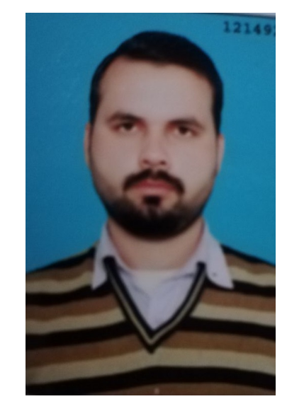

***Waseem Khan***

**Address:** Hassan Block, Nishter Colony, Feroze Pur Road Lahore.

**Mobile:** 0335-2190559

**Email:** [waseem.khn990@gmail.com](mailto:waseem.khn990@gmail.com)

## **OBJECTIVE**

Looking forward to join an environment of progressive organization that requires the energetic and proficient services where, I can utilize my abilities for advancement.

## **PERSONAL INFORMATION**

**Father's Name:** Ibrahim Khan Naz

**Date of Birth:** 9th Nov, 1990

**N.I.C No:** 35201-2380783-3

**Gender:** Male

**Religion:** Islam

**Marital Status:** Single

**Nationality:** Pakistani

## **QUALIFICATION PASSING YEAR INSTITUTE**

* **M.A English( Continue)** (2017) University of Sargodha
* **M.ed**  (2015) (University of Education)
* **B.ed** (2013) (University of Education)
* **B.Com** (2010) (Government Islamia Collage, Lahore)
* **I.Com** (2008) (BISE Lahore)
* **Matriculation** (Science) (2006) (BISE Lahore)

## **EXPERIENCES**

**Punjab Group of Colleges:**

**Designation:**

***Campus Coordinator cum Examination Officer***

18 August 2016 to till

**RESPONSIBILITIES:**

* To manage teacher duties.
* To manage class rooms.
* Solve student’s day to day issues.
* Keeping records and Filing system.
* Handling examinations matters.

**ZONG:**

**Designation:**

***CRO (Customer Relationship Officer)***

13th March, 2014 to 25th March 2015

**RESPONSIBILITIES:**

* Answer the calls in a good way.
* Solve all kind of queries or give the best solution according to the mental level of the customers.
* Keep updated through E-mail on every moment to give correct information/solution to increase the customer’s satisfaction level.

**Bakhtawar Public School:**

**Designation:**

***(Teaching*** *and* ***handling*** *all the* ***Administrative matters)***

1st August, 2011 to 28th February, 2014

**RESPONSIBILITIES:**

* Administrative arrangements (Faculty duties, date sheet, question papers, answer sheets, seating arrangements)
* Arrange Staff Meetings for the betterment of the Education and for the School also.
* Supervision the staff for Student’s Entry test, Interviews and Arrangements for new classes.
* Deal the Parents for new admissions and for any problem regarding Education or any other.
* Any other Duties assigned by Higher Authorities.

**Chaudary Rehmat School (Township): (Teaching)**

One Month Internship

**RESPONSIBILITIES:**

* Teach different classes and different subjects (English, Urdu, Pak studies, Islamic studies, Mathematics)

**COMPUTER SKILLS**

* Ms Office 2007,2010 (Ms word, Ms Excel, Ms Power Point)
* Good grip on Internet browsing

**ACTIVITIES & INTERESTS**

* Internet Surfing, Article writing and searching
* Traveling (with in Pakistan)

**LANGUAGES**

1. Urdu (native)
2. English
3. Punjabi

**Reference:**

Will be furnished on Demand.