**Waleed Bin Mustafa**

***Chemical Engineer***

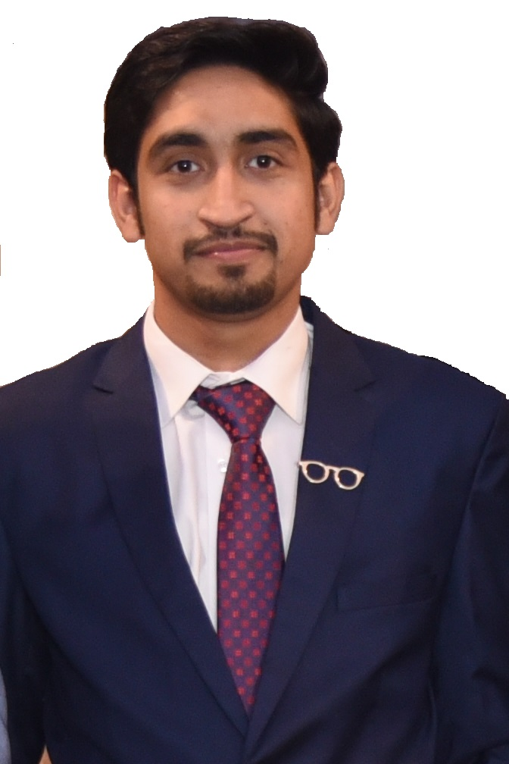



waleedmustafa1994@gmail.com

https://bit.ly/2Zb8eZK



+92 (323) 8814466

Waleedmustafa1994





@WaleedM06764866

August 01, 1994

Why ***Waleed?***

* Dynamic and motivated chemical engineer equipped with knowledge of multifarious areas of chemical engineering, reaction engineering, process designing & conversion and sustainable chemistry
* Diligent professional, with capable of conducting careful experimentation, developing deductive reasoning and performing systemized procedures to produce new products; suggests resourceful strategies and solutions to organizational challenges
* Performance-oriented individual apt at implementing leading-edge technologies and practices. Detail-oriented professional possesses immaculate reporting skills. Conversant with reviewing, developing and implementing policies and procedures

|  |  |  |
| --- | --- | --- |
| **CORE STRENGTHS & ENABLING SKILLS** | | |
| * Chemical Engineering * Process Designing * Research & Development * Reporting Skills | * Reaction Engineering * Analytical Chemistry * Materials Characterization * Communication & Presentation Skills | * C, MATLAB & Autodesk * AutoCAD & Microsoft Visio * Project Management | |

**PROFESSIONAL EXPERIENCE**

**D.G. Khan Cement Company Limited, Khewra, Pakistan**

Worked as *“****Chemical Engineering******Intern****”,* July 2016 – August 2016

**Responsibilities/Accomplishments:**

* Designed experiments, conducted tests and monitored & recorded results. Worked with various processing plants, gained insights into development of production processes and evaluated efficiency of production systems
* Determined feasibility of chemical procedures and ensured compliance with health and safety legislation; documented experiment results and gave recommendations; performed miscellaneous tasks assigned by supervisor

**PROFESSIONAL QUALIFICATION**

***Major Courses:***

|  |  |
| --- | --- |
| * Chemical Process Principles I & II * Fluid Mechanics * Thermodynamics I & II * Transport Phenomena * Chemical Process Technology * Petroleum Refining Engineering * Polymer Engineering | * Particulate Technology * Engineering Drawing * Mass Transfer * Heat Transfer * Fuel and Combustion * Chemical Reaction Engineering * Plant Design |

* **The University of Lancaster-UK**(2013 - 2017)

BSc. - Chemical Engineering

***Final-Year Project:***

* Production of Ethanol from Whey

4/1, Street No. 3, Saleem Park, PO Chah Miran, Lahore, 54900, Pakistan