**Khawaja Adnan Ahmad**

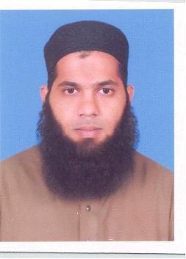

Address: 13-A Larechs Colony, Level Crossing No 4, Dryport, Mughalpura, Lahore, Pakistan

Mobile: +92-3344388997

Email: adnankhawaja727[@gmail.com](mailto:ibnkhattab02@hotmail.com)

**Objective**

Seeking a challenging position to utilize my skills and abilities in areas of teaching and education, that offers a professional growth, while being resourceful, innovative and flexible.

**Education**

2014-2016 **M.PHIL Commerce (2 yrs).**

University of Central Punjab (UCP) Lahore.

2009-2013 **B.Com (Hons.)**

Hailey College of Commerce (Punjab University), Lahore.

2007-2009 **F.sc (Pre Engg)**

Crescent Model College, Shadman, Lahore.

2005- 2007 **Matriculation**

Crescent Model Higher Secondary School, Lahore.

**Experience**

Mar-Aug, 2019 Lecturer at University of Education (Lower Mall Campus), Lahore.

**Informal Experience**

**Teacher**

* Private Tuitions’

Jun 2009- Present **Bookkeeper/Shop Manager**

* Business Equipment, Hall Road, Lahore.
* Handled all operations of the store including managing accounts and coordinating material handling and employee supervision.

Mar 2015 Attended workshop for SPSS and STATA software.

Nov 2019 Learned and attained basic understanding of Digital and Online Marketing at EBS&IT and ALM Company.

**Co-Curricular Activities**

2006- 07 Been an active part of Qasim house at Crescent Model Higher Secondary School.

**Skills**

* Communication
* Leadership skill
* Adaptability
* Content Writing
* Tutoring

**Languages**

* English-Fluent
* Urdu-Native
* Punjabi-Conversational

**Interests**

* Internet Browsing, Social Networking
* Current Affairs, Cricket
* Keen reader of historical fiction

**Personal Information**

* **Nationality:** Pakistani
* **Marital Status:** Single
* **Religion:** Islam

**Reference**

Director AR Job Consultant Regd

03130988438