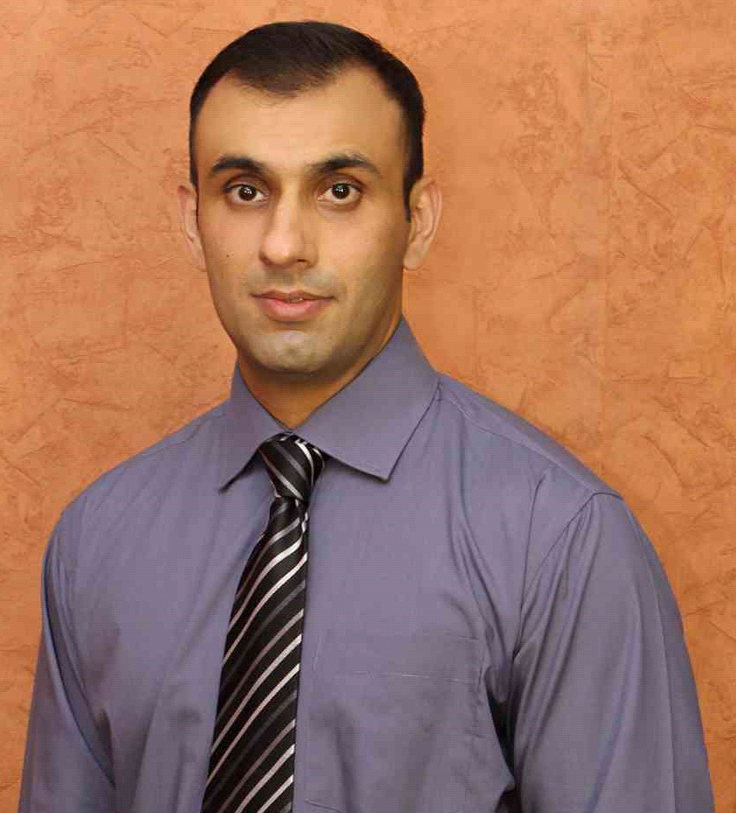**Yasir Rafique**

**Address: 408-K model town, Lahore**

**Email:** yas6488@gmail.com

**Phone: +923114499468,3004699455**

**D.O.B:** 12-09-1985

**Nationality:** Pakistani

**Skype id:** yasir652

**Marital status**: Single

**Professional Summary:**

U.K. educated **Student relationship Manager** used to work as an Assistant Client service Manager, looking for opportunities in similar fields in Pakistan. I am a motivated team player consistently aiming to meet, if not exceed, organizational goals. My experience in handling tough assignments at various organizations helped me develop a keen sense for innovative solutions to successfully and efficiently complete my tasks. Specialized in developing growth projects, I am not afraid to take on challenging assignments that would require me to work outside my comfort zone.

**Educational Qualification:**

Master in Marketing and Innovation 2012

*Anglia Ruskin University, Cambridge and Chelmsford, United Kingdom*

Postgraduate Diploma in Business Management 2011

*NCFE,(ATHE), London, United Kingdom*

Postgraduate Diploma in Business Administration 2008

*British Institute of Technology and E-Commerce, London, United Kingdom*

Bachelor in Commerce 2005

*Hailey College of Commerce, Punjab University, Pakistan*

**Professional Experience:**

**Student Relationship Manager/ Career Counselor Oct’19 till now**

**U2C Education Counselors, Phase 4 DHA Lahore**

Specializes in helpin students with their university applications to USA, UK, Canada, Australia, Europe and South East Asia also help with the career counselling and university short listing as well.

### Responsible for high school/A-levels and Undergraduate student scheduling.

* Monitor timelines and communicate status to supervisor

### Helped students make realistic choices about their education, training and work by providing information, guidance and advice.

### Helped identify options for suitable careers and CV writing; advised on where to search for admissions and locate relevant training courses.

* Assist in the development, editing, and production of materials, letters, forms, etc.

**Student Relationship Manager July’18 – Sept ‘19**

**University of South Asia, Barki Road Lahore, Pakistan**

* Create plans to address clients’ business needs.
* Understand requirement of each event and plan events with attention to financial and time constraints.
* Book venues and schedule speaker.
* Look and compare different vendors and negotiate with them.
* Track and overall expanses and stay within budget
* Evaluate event success and submit reports
* Oversees course scheduling, student enrollment, assessments, and student gains.
* Collaborates with College staff to facilitate the transition of students to College credit programs
* Oversees assessment and data management processes
* Act as point of contact for complaints and escalate issues as appropriate
* Ensure both the Administration and students adhere to contract terms
* Study competition to find new ways to retain students. .
* Collaborate with internal teams (e.g. sales, senior management) to address students’ needs
* Analyze current practices and conduct research on improvements.
* Update materials, schedules, requirements and provide information to students/participants and resolve problems

**Assistant Manager Client Relations Jan’16 – Jun’18**

**Bismillah Carpets, Lahore, Pakistan**

Bismillah Carpets is the manufacturer and exporter of hand knotted carpets. Majority of the carpets are exported

* Build relationships with key employees among customers
* Assisted Manager in managing Export related projects.
* Carried out market research in order to keep up to date with customer trends, as well as tried to predict future trends
* Assists in the management, maintenance, and operation of facility
* Analyze the success of marketing campaigns and creating reports
* Supervise advertising, product design and other forms of marketing to maintain consistency in branding
* Managing budgets and a team of junior assistants
* Organising events such as product launches, exhibitions and photo shoots
* Schedule regular meetings with customers to ensure they are satisfied
* Act as point of contact for complaints and escalate issues as appropriate
* Ensure both the company and clients adhere to contract term

**Senior Career Counselor Aug’14- Dec’15**

**Success and Ideas Education and Business Consultancy, Lahore, Pakistan**

Success and Ideas one of the pioneers among all the Counseling agencies in Pakistan. Every year majority of the university placements including Ivy league are from Success and Ideas.

### Responsible for high school/A-levels and Undergraduate student scheduling.

* Monitor timelines and communicate status to supervisor

### Helped students make realistic choices about their education, training and work by providing information, guidance and advice.

### Helped identify options for suitable careers and CV writing; advised on where to search for admissions and locate relevant training courses.

* Assist in the development, editing, and production of materials, letters, forms, etc.
* Update schedules, requirements and provide information to students and resolve problems
* Assist in preparing reports and program documentation
* Planned Event or activities regularly and on some occasion and got approved from senior management.
* Proofreading emails for clarity, grammar, and spelling.

**Site Manager Jan ‘13 - Jun ‘14**

**Gunyah Ltd, Shell Oil U.K. Ltd., United Kingdom.**

*Gunyah Ltd. owns 10 different franchises of Shell Oil, UK, and specializes in working with a multitude of companies dealing in oil, gas and lubricants. Shell helps meet the world's growing demand for energy economically, environmentally in a socially responsible ways****.***

* Recruit, hire and provide orientations for newly inducted employees.
* Meet with all the workers on a regular basis to review files and circumstances.
* Provide workers with information on maintaining their jobs..
* Provide workers with information on dealing with job dissatisfaction.
* Documenting human resource actions; completing forms, reports, logs, and records.
* Maintaining contract with the vendors for new product purchases.
* Keeping track of the earnings originating from retail operations; providing reports to the owner of the gas station in question.
* Understanding current and potential customers.
* Making customer focused decisions.

**Additional Skills and Personal Attributes:**

* Proficient in using Microsoft Applications (Word, Power Point, Excel).
* Administrative support.
* Organized and detail oriented.
* Ability to lead and work within a team.
* Dedicated and focused.
* Bilingual.

**References:**

Mr Ali Imran

Director Human Resources University of South Asia

#: +923219433299 @: ali.imran@usa.edu.pk

Mr Iftikhar-ul-Qamar

COO and Founder of Bismillah Carpets , Lahore, Pakistan

#: +923008461050 @: [bismillahcarpets@gmail.com](mailto:bismillahcarpets@gmail.com)

Mr Ali Mustafa

COO and Founder of Success and Ideas, Lahore, Pakistan

#: +923334327774 @:successandideas@gmail.com

Mr Nadeem Hussain

COO, Gunyah Ltd working in Partnership with Shell Oil, UK

#: 0044 20 8983 2500 @: [z_dar@hotmail.co.uk](mailto:z_dar@hotmail.co.uk)

Dr George Panagiotou

Director, Academic & Quality Compliance at London School of Education Group, London School of Marketing, UK

#: 0044 20 7201 4304 @: [dr.g.panagiotou@lseducationgroup.com](mailto:dr.g.panagiotou@lseducationgroup.com)