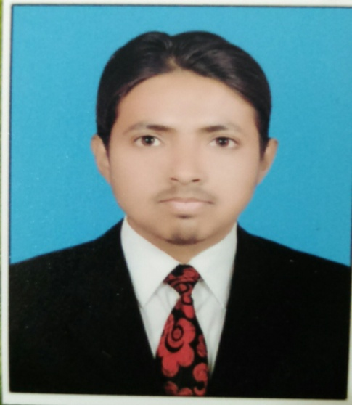***Name:*** *Zeeshan Ali*

***Email:***  zeeshanalics20@gmail.com

***Cell No****:*  +92306-8470177

***Address:*** Mian Channu Dist. Khanewal

CAREER OBJECTIVES:

*I am an enthusiastic professional possessing sound personality with all the Characteristics necessary for the accomplishment of assigned job, performing duties to the entire satisfaction of the superior with full zeal, diligence. I would like to become a competent professional and utilize the constructive energy & vision to aggressively & responsibly handle the present & future needs of an organization through dedication & commitment to the profession. I would like to work in the field of computer.*

Experience:

* **Lab Assistant:**

*Organization:*  **Fauji Foundation (Khanewal)**

*Duration:* **Continue….**

* **Lecturer:**Organization: **Government Degree College (Mian Channu)**

Duration: **6 months.**

* **IT Internee/ IT Department:**

Organization**: Jamhore Textile Industry (Mian Channu)**

Duration**: 2-Months**

* **Hostel Audit Officer (Audit Committee Member)**

Organization**: KFUEIT Sir Syed Hall (Rahimyar Khan)**

Duration**: 2-Semesters**

* **Library Committee Member (Friends of Library FOL)**

Organization**: KFUEIT General Library (Rahimyar Khan)**

Duration**: 2-Semesters**

* **Scienc Hub Committee Member (CO_MEDIA HEAD AND THIRILAN)**

Organization**: KFUEIT Science Gala (Rahimyar Khan)**

Duration**: 2-Semesters**

PERSONAL DETAILS:

***Father’s Name:***   *Habib Ur Rahman.*

***Date of Birth*:** *09 Jul 1994.*

***Address*:**  *A.S Bag Store Bano Bazaar Mian Channu.*

***Nationality*:**   *Pakistani.*

***Domicile*:** *Khanewal (Punjab).*

***N.I.C No.*:**  *36104-5930412-5.*

***Religion*:** *Islam*

***Marital Status*:** *Single*

***Languages*:** *Urdu & English*

ACADEMIC RECORD:

|  |  |  |  |  |  |
| --- | --- | --- | --- | --- | --- |
| ***Degree*** | ***Year*** | ***Div.*** | ***Marks/CGPA*** | ***Percentage*** | ***Board/University*** |
| *BSc Computer Science*  ***BSCS*** | *2014-2018* | *1st* | *2.94/4.00* | *73%* | *Khawaja Fareed University of Engineering & Information Technology (KFUEIT) Rahim Yar Khan* |
| *FSc (Pre-Engineering)*  ***HSSC*** | *2012-2014* | *1st* | *742/1100* | *67.77%* | *BISE Multan* |
| *Matriculation (Science)*  ***SSC*** | *2010-2012* | *1st* | *904/1050* | *89.33%* | *BISE Multan* |
| *Certificate in Computer Applications*  ***CCA*** | *2016-2017* | *1st* | *94/100* | *94%* | *TEVTA*  *GCT-RYK.* |

COMPUTER SKILLS:

* *MS office (6 Months short course of CCA 94%)*
* *Internet Operations*
* *Producing & maintaining office record*
* *Coding in C++, Java, Android, Python, PHP etc. high-level languages.*
* *Computer Security (Data and Network security.*
* *Networking (CCNA).*
* *Wordpress and Shopify developer*

PERSONAL SKILLS:

* *Ability to rapidly build relationship and setup trust.*
* *Ability to cope up with different situations.*
* *Ability to work individually as well as in group.*
* *Strong motivational and leadership skills.*
* *Confident and determined.*
* *Good computer user.*
* *Hostel Management Skills*
* *Library Events organizing skills*

FYP/Final Year Project:

***Title: Intelligent Warehouse Manager***

* During studies, Lead project team on term project.
* Designed the whole software model and Data Flow Diagram
* Presented proof of functionality and concept at project exhibition for further perusal of the industrial application of the project

Intrest/Hobbies:

* + - * Football
      * Cricket
      * New Technologies
      * Chess
      * Study deeply and researching
      * To do new Projects.
      * Like taking tea.

REFERENCES:

* *Will be furnished on demand.*