# PROFILE

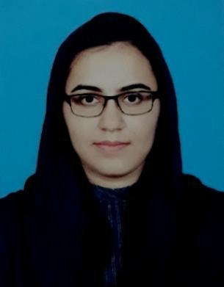

## Name : Iqra Mujahid Father Name : Mujahid Ali Nationality : Pakistani Domicile: Punjab

Marital Status : Single Language : English / Urdu

CONTACT

0332-4130649

[iqra.mujahid13@gmail.com](mailto:iqra.mujahid13@gmail.com)

House Number 292, block 4, sector A2,

Township, Lahore.

# ABOUT ME

## I am an honest, focused and vigilant individual who works with effective dedication and strong commitment to bring fruitful outcomes of the set targets.

BELIEVE – WORK – CHANGE

IT Skills

MS office

(Word, Excel, PowerPoint, Outlook) InPage

Interactive white boards and tablets Internet Surfing and Gmail Computerized Accounting (Peachtree, Tally ERP9, Sage, QuickBooks, Excel)

Workshops & Trainings

Spoken English (2008)

Qasr e Behbood Institute for women Pakistani cuisine (2008)

Qasr e Behbood Institute for women Computer Information & Technology (IT Basic)

From Citizen College of Computer Sciences (2010)

Effective Classroom Management & Teaching Strategies (2013)

By paramount publishing Enterprises Effective Teaching Strategies

By Ali Institute (2013)

IQRA MUJAHID

Teacher Coordinator

Learner

# EDUCATION

 University of the Punjab (2016)

### Master’s degree Commerce

 University of the Punjab (2012)

### Bachelors of Commerce

 Kinnaird College for women (2010)

### Intermediate General Science

 The Punjab School (2008)

### Matriculation Science

 6 months diploma in professional cooking plus internship

EXPERIENCE

 Sr. Sales Coordinator [Coral Enterprises Ltd. (2017)]

“Had been mainly responsible for

* Assisting the National Sales Manager in keeping follow up of sales team working all over Pakistan.
* Submitting assigned reports on daily basis to COO, NSM and other concerned personnel.
* Effective coordination, with clients and departments for achieving set targets”
* coping up with job dilemmas according to the relevant SOPs.
* Following up the performance of sales team.

 Substitution teacher

[PakTurk International schools and colleges (2016)]

## Mathematics teacher; Middle Section

[EPIC School of Contemporary and Islamic Studies (2014-2016)]

## Mathematics teacher; Junior & Middle Section

[Al_Aꞌlā International Islamic School (2012-2014)] Major responsibilities

* Created comprehensive lesson plans incorporating various methods of teaching to ensure pupils are actively engaged and understand the materials
* Collaborated with colleagues to integrate new activities and allocate effectively the available resources.
* Participated in meetings and professional development seminars.
* Developed and introduced an enrichment program for students who were not quite equipped to move on to the next level
* Served on the Math Department’s Planning Board
* Implemented stimulating lessons to engage students’ attention and interest, allowing them to develop a passion for the subject
* Offered after-school tutoring to aid struggling students to improve their academic performance

   

# HOBBIES

## Learning more about my interests Socializing



 Badminton